Curriculum-Vitae
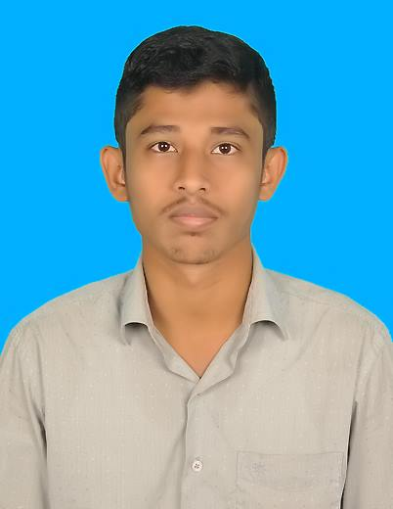

Adhil
Adhil.349374@2freemail.com

CAREER OBJECTIVE:

Want To Change The Career Path. Want To Achieve Success Through Working In A Challenging Position (Arabic Typing and Any Administrative Work), To My Fullest Ability For The Betterment Of The Organization As Well Myself.

PROFESSIONAL EXPERIENCE:

- Process Associate

HTC Global service, Chennai 48. -- One Year

- Front Office Executive and DTP Works

INSTA COMPUTER EDUCATION, LALPET, TAMIL NADU.1st –Aug-2016 to 26th –Feb 2017

Client Served Under My Tenure:

- Arabic Process Associate and Typing

RESPONSIBILITIES:

- Office Administration Work (Dealing With Courier Services – Internal Within Departments, Sections, Subsidiaries)
- Visitors Management (Accommodating Visitors Through Seating Arrangements, Arranging For Their Reception)
- Possess excellent typing skills
- Excellent written and verbal communication skills
- Formatting documentation
- Creating documents
- All other types of administrative duties related to office management.

SUMMARY OF SKILLS:

- Good Command Over Customer Relationship Management
- Having Good Command Over Languages Like Arabic, English, Tamil
- Effective Team Player, Highly Self-Motivated, Known For Creativity, Flexibility and Sense of Humour.
- Have The Capability To Work Under Pressure
- Believe In Punctuality, Neatness, Confidence, Patience, Willingness To Take Reasonable Risks, Goal Oriented, Etc.

ACHIEVEMENT:

- Winning Capability Of The People Whom I Serve Or Provide Service
- Good Command Over Customer Relationship Management - (As Working In Service Based Industry Dealing On A Daily Basis With Different People (Different Nationalities)

COMPUTER PROFICIENCY:

- Windows Operating Systems
- Ms Word, Excel, PowerPoint.
- Internet and Email
- Corel Draw
- Typing Arabic and English

EDUCATIONAL QUALIFICATION:

- B.A. (Islamic studies B.S.A University, Chennai (2012 to 2015) ( Regular )
- B.B.A Madras University ,Chennai (2012-2015) ( Correspondence )
- Aalimiyat, Bhukhari Arabic college, Chennai ( Islamic degree )
- Hsc Bhukhari Arabic college, Chennai
- Sslc Imam Gazzali Matric Hr Sec School, Lalpet

I Hereby Declare That The Above Mentioned Information True To My Knowledge.

