SanthoshKumar
SanthoshKumar.349387@2freemail.com

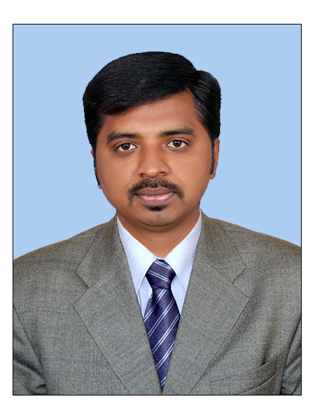
5.11 Experience, in Warehouse, Logisticsand SCM

EDUCATION

MBA [HR and Marketing]
2009-2011
Anna University

BBM [Business Management]
2006-2009
Bharathiyar University

TECHNICAL

SKILLS

- SAP MM, SD and Basis

- MS Office tools

- Lotus Notes

LANGUAGE
- English

- Tamil
- Malayalam

WORK HISTORY

Mar 2015 - Robert Bosch Engineering
^{Jan 2017}
Senior Associate – Warehouse & Logistics

- Driving projects with customers to improve delivery performance and quality within supply chain
- Extended support to the project of warehouse management in Automotive Electronics , Power Tools Division and Driving Control Division
- Review in planning of post deliveries activities, soul responsible to Co-ordination between Forwarders, Central Department Warehouses and Bosch plants to ensure collect the ‘Proof of Transport’
- Managing the inventory and warehousing operations such as goods receipt, storage, picking and goods dispatchUpdating inventory and stockroom reports periodically.
- Provided support in Deliveries confirmation, tracking of Confirmationdeliveries generation project related documents;
- Coordination with customers’ requirements with relevant functions in Bosch plant and central logistics divisions
- Provided support towards with internal or external related queries
- Key-user in SAP (MM.SD,Basis)and Business Intelligence tool for report generation

Aug 2012 - VWR International LLC,
^{Mar 2015}
Process Associate - Supply ChainManagement & Warehouse

- Creating purchase orders, sales orders, service orders, invoices and billing documents using SAP MM and SD.
- Tracking order status and product shipments.
- Create packing lists and update shipment information in database
- Monitor and facilitate repair orders
- Coordinate deliveries for repaired or returned items
- Conduct safety procedures for outbound shipment vehicle
- Batch Management: Determining batches for sales orders and deliveries.
- Interact with third party logistics service providers
- Maintain communication with warehouse staff to ensure proper work order
- Processing EDI orders, invoices and quotations. Creating Credit and Debit memos.

KEY SKILLS

- Logistics support
- Warehouse maintenance
- Order Tracking
- Vendor Management
- Materials Management
- Customer service
- Order Management
- Project Management
- International Calling

COMPETENCIES

- Attention to detail

- Qualitative

- Data Analysis

- Communication

- Work with deadlines

- Positive attitude

- Public Speaking

- Problem solving

- Planning & Prioritizing

May 2011 - Schumak Equipments India Pvt Ltd
^{Jun 2012}
Asst.Manager - Supply Chain Management

- Preparing delivery plan, and resource allocation
- Site surveying, warehouse maintenance and inventory control.
- Assigning tasks for sub-ordinates and supervising the workflow.
- Maintained Tele-enquiry and Emails and sending Quotations based on the requirement
- Supervise orders and arrange stocking of raw materials and equipment to ensure they meet needs.
- Monitor supplier performance to assess ability to meet quality and delivery requirements.
- Monitor forecasts and quotas to identify changes or to determine their effect on supply chain activities.
- Monitor incoming supplies for quantity and quality
- Process logistics requests from various management sources
- Maintain safety of property
- Manage paperwork associated with shipping duties
- Interface with vendors and clients to ensure proper delivery of shipment
- Ensuring the completion of the project and documentation

CLIENT FOCUS

- Ensuring high quality services that result in client delight
- Responding to clients' requests immediately.
- Ability to retain customer's goodwill by providing an extra effort in resolving issues.
- Building an excellent rapport with vendors to get the job done.

CORE COMPETENCIES

- Excellent team player and mentor.
- Good communication and presentation skill.
- Strong process knowledge and result oriented approach.
- Flexibility in working.

ACHIEVEMENTS

- BOSCH Awarded with " Excellent performer" in [2016] Certification for Best process lead
- VWR Awarded with "Star performer” [2014 & 2015] Certification for Best Employee
- Appreciation from Stake holder for excellent support. Exceeded KPI and productivity target throughout the year [2014 & 2015].

