Muhammad
Muhammad.349522@2freemail.com
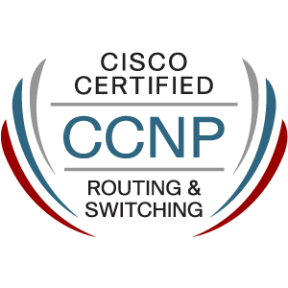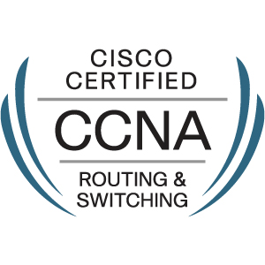
Objective
A highly motivated and dedicated network professional with 3 years extensive experience on enterprise network, now I’m looking for a dynamic and challenging role in the area of computer networking/administration that will offer me the best opportunities for the further development of my abilities, skill and knowledge in an established firm with long term career growth possibilities.
Professional Experience:
Jr. Network Administrator: EGS Private Ltd.
Duration: January 2016–February 2017
- Computer and network management (LAN and WAN)
- Diagnose issues and Troubleshoot in Local Area Network.
- Install and support LAN, WAN, and Branches networks.
- Configured and maintained routers, Switches and firewall.
- Ensured that the LAN is operational and available to users at all times.
- Creating infrastructure of wiring and install LAN/WAN network components.
- Install and maintain Windows Server 2003, 2008, 2012 and client operating systems.
- Administering Domain Controller, DHCP, DNS, Proxy server including Virtual Machines.
- Provided technical support to computer system users on reported issues and service requests.
- Maintained network security standards and escalation of situations requiring urgent attention.
- Created and maintained documentation relating to network configurations, network diagrams.
- Administering and maintain user accounts, permissions, access rights and mailbox.
- Monitored Windows Server performance and Symantec anti-virus software.
- Manage and maintain data backup according to Data backup policy.
- Installation and support Oracle database 9i, 11g, and Pibas Banking Applications.
- Installation and Support Bio-metric systems.
- Maintain IT inventory updated of all IT related equipment’s and licensed software’s.
- Coordinating with vendors and ISP’s.
IT. Coordinator: EGS Private Ltd.
Duration: March 2014–December 2015
- Installing and configuring Servers and Clients computer systems.
- Diagnosing and solving hardware issue/ update software patches.
- Setting up new user’s accounts and profiles and dealing with password.
- Conducting electrical safety checks on IT equipment.
- Collaborating with MIS and IT departments.
Technical Certifications
Cisco Certified Network Professional CSCO
Cisco Certified Network Associate CSCO
Microsoft Certified System Administrator 2012
Education
Bachelors in Communication University of Sargodha (2011-2013)
Projects
Disaster Recovery Project
Setup of network for new opening branches and DR-Site
Configure RAID 5 on Server 2008
Configure Business VPN on HUB and Spoke Network
Hands on Experience
Cisco Router series 2500, 2600, 2800, 2900, 3800, 7200
Cisco/Catalyst switches 2950, 3550, 3560, 3750, 4500
Window Server 2003/2008 and 2012 including Hyper-V
Technical Skills
- Computer and network management LAN and WAN.
- Local Area Network (LAN) Protocols and configuration.
- Wide Area Network (WAN) Protocols and configuration.
- Structure network cabling such as STP, UTP etc.
- Installation and configuration of LAN, WAN and wireless networks.
- Configuring troubleshoot and management routing protocols (OSPF, EIGRP, BGP, RIP)
- Configuring and implementation of IGP and EGP.
- Policy Base Routing/Redistribution.
- Configure EBGP and IBGP (Full mesh and Route reflector)
- Configure and troubleshooting STP and VLAN’s.
- Configure and troubleshoot Layer 2 and Layer 3 EtherChannel.
- Configure and troubleshoot First Hope Redundancy Protocols.
- Configure and troubleshoot Layer 2 port security protocols and AAA model.
- Configure and maintain Data backup according to Data backup Policy.
- Proficient using the Microsoft products and operating systems.
- Installation and configuration Window Server 2003, 2008 and 2012.
- Installation and maintain Hyper-V machines on window Server 2008 and 2012.
- Administering Domain Controller, file server.
- Upgrade IOS of Cisco Routers and Switches.
Personal Skills
- Willing to travel to client sites.
- Excellent judgement and decision making.
- Giving full attention to what other people are saying.
- Ability to work well with others.
- Can work comfortably within a deadline driven environment.
- Performing well in stressful situations.
- Able to follow directions and work independently.

