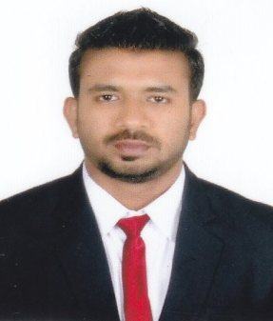
  - To continue my career with an organization that will utilize my management, accounting and selling skills to benefit mutual growth and success.Competent and diligent professional with proven Leadership and decision-making skills, self-motivated with excellent financial analysis skills and critical thinking, pays attention to detail and works well under pressure. Able to prioritize to ensure that deadlines are met whilst maintaining a high standard of analysis and insight.

ACADEMIC QUALIFICATIONS

Course | Institute/College  /School | University/ Board | Percentage/ CGPA | Year of Passing
PGDBA | Adarsha Institute of Management | Goa University | B | 2015
B.Com | Goa University | Goa University | 70% | 2013
Std XII | Government Higher Secondary,Valpoi | Goa Board | 57% | 2010
Std X | Unity High School | Goa Board | 53% | 2008

INTERNSHIP & PROJECTS

Schneider Electric India Ltd, Verna, Goa (28th April 2014 – 12th July 2014)
- Role: Management Trainee
- Responsibility: worked under each department to complete the project assigned (StockManagement)

HDFC Bank Ltd (24TH December 2014 - 28TH DECEMBER 2017)

PERSONAL BANKER / ASSISTANT MANAGER

- Evaluated and improved quality of portfolios, credited for consistently maintaining highest quality portfolios, which included managing highly sensitive corporate relationship.
- Ensured accurate handling and monitoring of remittances.
- Achieved revenue and customer retention goals while increasing client profitability through relationship building, outstanding service delivery.
- Cross-sold bank products and services to increase sales and revenues.
- Balanced daily cash transactions and reconciled daily transactions to ensure accuracy.
- Facilitated implementation of new and revised policies and procedures throughout branch and department.
- Helped new and existing clients open personal accounts, resolve issues related to online banking services, and navigate bank’s website; assisted corporate and small business account with online business banking.
- Unlocked locked accounts and provided temporary passwords to provide access to online accounts.
- Worked with advertising and marketing team to promote new product of company e.g. digitalization or life insurance product.
- Developed strong rapport with branch managers and provided administrative support at local branches during staffing shortages.
- Maintained strict confidentiality for all client information.
- Maintained and updated office process reports on a regular basis.
- Updated high-value profiles and portfolios for important clients.

COMPUTER KNOWLEDGE
- Proficient or familiar with technologies, including: Operating Systems – Windows XP\Vista\Windows7\8
- MS Word, MS PowerPoint, MS Excel and Photoshop
PROJECTS
- Project on feasibility study to start a multiplex in town.
- Project on stock management in Automobile Corporation of Goa Ltd.

ACHIEVEMENTS
- Awarded for achieving Bank Targets by Circle Head of the Bank.
- Felicitated by “Popular Front of India” for scoring distinction in B.com.
- Awarded for top 10 outgoing students from college.

EXTRA CURRICULAR ACTIVITIES
- Participated in banking programmes and competitions
- Participated in various inter college competition
- Member of organizing committee for the events “Razzle Dazzle” & “Puzzle Mania”.
- NSS volunteer.
- Member of Phoenix Club.

