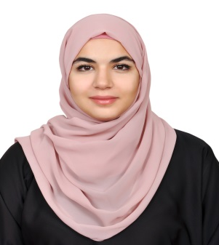
Fatima
Fatima.349586@2freemail.com

Objective
To obtain a position at a well-established growing company in which I can positively contribute to its success and employ my skills and education, I want to eventually expand my administrative, financial, and managerial knowledge and experience.

Education
- Bachelor of Sciences in Accounting, CGPA 3.71/4.0 2012-2016
Ajman University of Science and Technology
United Arab Emirates, Ajman
- High School degree, scored 99% 2012
Al Estiqlal Private School
United Arab Emirates, Sharjah

Achievements and activities
Member of business clubs at Ajman University 2013
Member of the university’s sports committee 2015-2016
Vice president of High School student council 2012
Awarded by the Ministry of Education of Sharjah for excellent academic performance 2012

Skills
- Fluent in English (writing and speaking), and Arabic
- Proficient in Microsoft Office (MS Word, MS PowerPoint, and MS Excel)
- Online research
- Leadership skills
- Excellent Communication skills
Work experience
Municipality of Sharjah City 6th March-26th April
Internship at the Financial Administration
I Received Training in four different departments: Treasury, Accounts, Budget, and Revenue. The exposure to daily accounting tasks further developed my experience at multitasking, time management, as well as data entry and bookkeeping.

References
Available on request

