Resume
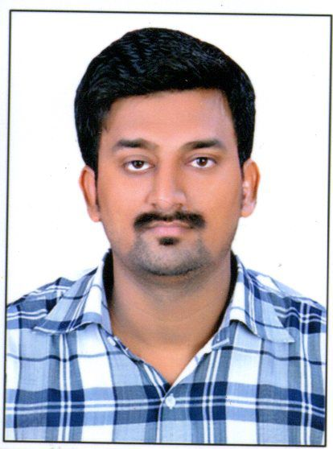

DIWAKAR
DIWAKAR.349596@2freemail.com

Objective
To secure a position in an organization , where I can utilize my knowledge, skill and my experience for the growth of organization.
Brief Overview
- B.Tech (Civil Engineering & Diploma in Architecture ) with expertise in Execution Civil Engineering Drawing and Architectural Drawing.
- 03 year experience as an asst. architect .
- Through Understanding of the working of the as well as Implementation of R.C.C as well as architectural.
- Endowed with good problem solving capabilities under pressure.
- Posses an analytical mind with good problem solving skills.

Work Profile
Present Employee:-
- Organization : Laxman Appa & Co..
- Location : A -416,City Mall Bldg.,Turbhe,Navi Mumbai
- Duration : 07 October 2016 to Till Date
- Designation : Site Co-ordinator
Work Experience
- 1 year 10 month Experience as site engineer in R.N.A Builders (NG)in Ghansoli Navi MumBai From 26th Feb 2014 to 05 December 2015
- 2.5 months vocational training at guruatman project(Kalyan) in 2013.
- Work as a asst. architect in Shiv Ram Builders , Allahabad ( U.P)from Oct 2007 to March 2011.
- Work in Design Corner ,dhanbad (Jharkhand) as a trainee from oct 2006 to April 2007

Job Profile

- To execute the site as per steel structural dwg.
- To check civil drawings and architectural drawings and liaison with consultants and architect.
Responsibilities:-
- To ensure that there are no errors in the drawings.
- To ensure that work is progressive as per planning schedule, quality and budget.
- Daily supervision &Progress report generate.
- Planning of all Project execution and Quality check.
Authorities:-
- To release ready for construction drawings.
- To inspect and authorize work, to stop non confirming work.

Job Description:-
- Preparation of D.P.R (Daily Progress Report) and D.L.R(Daily Labor Report),Checking of columns and slabs dimensions & reinforcement.
- Familiar with the checklist of cement, sand, bricks concrete etc.
- Estimation of quantities of concrete, steel and all other civil items.
- Good co-ordination with contractor as well as foreman and labor.
- Knowledge of water proofing, brick work, internal plaster & external plaster of superstructure.
- Co-ordination with clients and contractors.
- Estimation of the Quantities of steel & concrete.
- Preparation of Daily Progress Report.
- Execution of site work.
- Preparation of BAR BENDING SCHEDULE.
- Estimation of Quantities of Concrete, Steel & Shuttering etc.
- Execution of R.C.C work etc.
- Preparation of pour card & B.O.Q etc.
- Site supervision for all the activities on site.
- Checking bar bending schedule .
- Making indent for steel and concrete .
- Contractors bill checking and certification .
- Planning activities at site and meeting with contractors.
- Tracking the activities as per schedule.
- Checking of sieve analysis of aggregates as per IS Code.
- Prepare the bar chart and follow the progress of work as per schedule.
Academic credentials:-
- B.TECH (Civil Engineering) from Uttar Pradesh Technical University with 66.7 % marks in 2016.
- Diploma in Architectural Engineering from Uttar Pradesh Technical University with 63% marks in 2006.

- Intermediate from Hanuman Singh Inter Collage, Deokali Ghazipur (U.P) in 2003 secured 1st division with an aggregate of 64%.
- Matriculation from hanuman Singh Inter Collage, Deokali Ghazipur (U.P) in 2001 secured 2nd division with an aggregate of 59%.
Additional Skills:-
- Auto cad ( 2D )

IT Skills:-
- Operating system :Windows XP/007
- Office Automation Program : MS Word / MS Execl
About the Working Projects –
N.G. Grand Plaza (project name) at ghansoli in navi Mumbai , I have started yet till foundation and completed upto stilt & first after I am engaged in other sites of R.N.A Builders in brickwork,plasterwork ,finishing work
Presently I am working as a Site Co-ordinatior of Laxman Appa & CO. , handling all the running sites & Visit the sites alternate to check the progress & quality of the work.
Hobbies:-
- Playing cricket

Current Salary - 25000/Per Month
Notice Period - Completed
Total Experience – 02 years

DECLARATION
I hereby affirm that the above information is true to the best of my knowledge.

Date
Place-

