CURRICULUM VITAE: ICEL
ICEL.349600@2freemail.com

CAREER OBJECTIVE
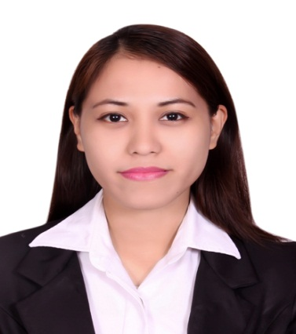

ATTRIBUTES & SKILLS:
- Ability to work independently.
- Committed to provide excellent customer service all times.
- Proficient in MS Office applications.
- Knowledgeable in Visual Basic Program.
- Have a basic knowledge in CISCO Networking.
- Knowledgeable in Web Designing (HTML-PHP-MySql)
- Knowledgeable in Computer Hardware.

DATE OF BIRTH
August 05, 1990

NATIONALITY
Filipino

MARITAL STATUS
Single

LANGUAGES
Tagalog &Visaya
English: Excellent (both verbal and writing).

VISA STATUS
Residence Visa

AVAILABILITY
Immediately

EXPECTED SALARY
Negotiable

References: (Available upon
request).

I hereby certify the above information are true and correct to the best of my knowledge.

To pursue a highly rewarding career, seeking for a job in challenging and healthy work environment where I can utilize my skills and knowledge efficiently for organization growth.

EDUCATION

Bachelor’s Degree  B.S. in Information Technology
School  Mindanao University of Science and Technology
Address  Cagayan de Oro City, Philippines
Date Graduated  April 2011

PROFESSIONAL EXPERIENCE

Present
SAMA ALSHAM DENTAL CENTRE
Abu Dhabi, UAE
Position: Receptionist/Secretary

Duties and Responsibilities: Communicate with customers, employees, and other individuals to answer questions, disseminate or explain information, take orders and address complaints. ● Answer telephones, direct calls and take messages. ● Compile, copy sort, and file records of office activities, Checking eligibility, handling dental insurances, and other activities ● Complete and mail bills, contracts, policies, invoices, or checks. ● Operate office machines, such as photocopiers and scanners, facsimile machines, voice mail systems and personal computers. ● Compute, record, and proofread data and other information, such as records or reports. ● Maintain and update filing, inventory, mailing and database system, either manually or using a computer. ● Open, sort and route incoming mail, answer correspondence and prepare outgoing mail.

September 2013 – September 2015
United Hospitality
Abu Dhabi, United Arab Emirates
Position: Food & Beverage Attendant

July 2011 – August 2013
Cagayan Electric Power and Light Company, Inc. (CEPALCO)
Cagayan de Oro City, Philippines
Position: Project CMS Staff (Casual)

AWARDS ANDSEMINARS:

- Best in Project Proposal (Web-based Assessment System) SY: 2010-2011
- Search Engine Optimization, MUST-Cagayan de Oro City, February 2011
- Latest Trends in Networking Technology, MUST-CDO City, February 2011

