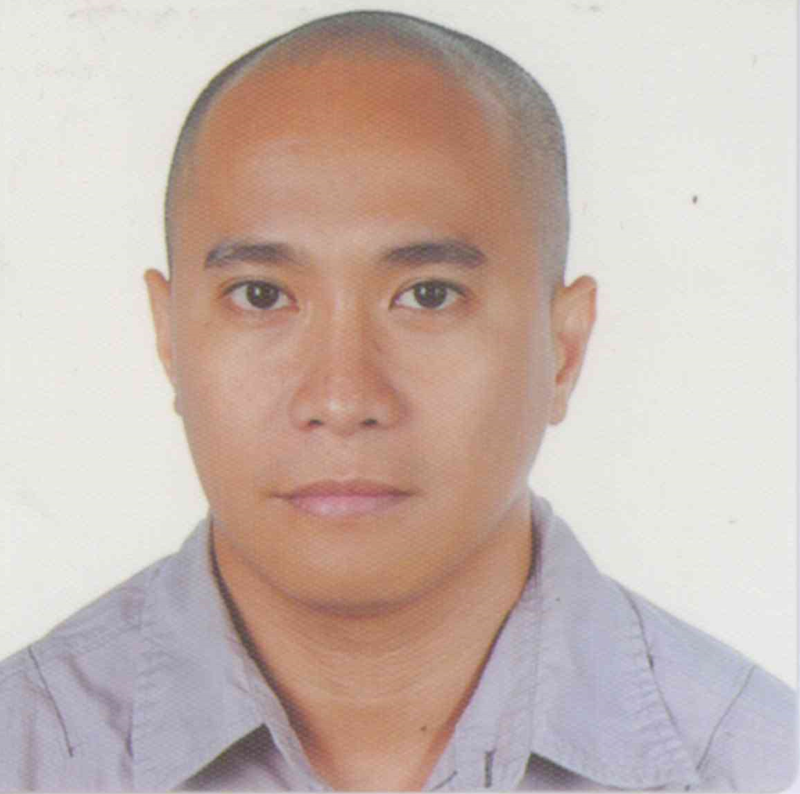
VINCENT
E-mail: VINCENT.349629@2freemail.com

OBJECTIVE

- To apply for a position commensurate with my qualifications

PERSONAL INFORMATION

Age: 33 years old
Birthdate: April 9, 1983 Place of Birth: Mandaue City, Cebu
Civil Status: Married Citizenship: Filipino
Sex: Male Religion: Roman Catholic
Height: 5’4” Weight: 63kgs.

EDUCATIONAL BACKGROUND

College: Bachelor of Science in Electronics and Communcations Engineering
University of San Carlos
Talamban, Cebu City
2000 – 2005
High School: St. Louis School of Mandaue
Maguikay, Mandaue City, Cebu
1996 - 2000
Elementary: St. Joseph’s Academy
Mandaue City, Cebu
1990 – 1996

ACHIEVEMENT

- Passed the April 2006 ECE Licensure Examination

TRAININGS/SEMINARS

- 3G Technology
May 6, 2006
Montebello Hotel, Banilad Cebu City

- Schneider Structured Cabling
August 9, 2009
Schneider Electric Office, Mandaue City

- Panduit Enterprise Network Solutions
May 20, 2015
Cebu City Marriott Hotel, Cebu City

- Lilin Network Cameras
August 28, 2015
The Monastery, Lahug, Cebu City

- Axis Product and Technology Update
February 2016
MEC Knowledge Hub, Cebu Business Park, Cebu City

SKILLS
- Extensive knowledge of technology terms and developments
- Excellent written and verbal communication skills
- Ability to instruct users with computer and presentation skills
- Exceptional customer service skills
- Ability to work with Windows and MAC Operating Systems
- Ability to setup audio systems (amplifiers, mixers, speakers, dj controller, dmx controller)
- Able to repair, install, upgrade, and maintain desktop and notebook computers as well as printers and scanners
- Able to repair circuit boards

WORK EXPERIENCE
HPS ICT Inc.
Plaridel St. Alang-Alang, Mandaue City
Position: Project - in – charge / Technical Support Engineer (Structured Cabling for Voice and Data)
Employment Period: July 20, 2014 – November 30, 2016
Major Projects assigned/handled:
-Cebu Holdings Inc., affiliate of Ayala land. Inc. (horizontal cabling for voice and data with CAT6 and CAT6A and fiber optic backbone)
-University of Cebu Medical Center (horizontal cabling for voice and data with CAT6 and CAT6A riser backbone)
-First Consolidated Bank (troubleshooting and repair of inter-branch Fiber Optic cable backbone)
Job Description:
- Supervises the installation, modification, repair and maintenance of voice, and data cabling systems
- Work closely and coordinate with other contractors during installation
- Attend weekly MEPF meetings and submit progress reports
- Assembly and configuration of MDF/IDF equipment ( i.e. racks, patch panels, switches, routers, PABX)
- Install WIFI/Access Points, CCTV cameras
- Termination, testing and troubleshooting of fiber optic cables
- Testing systems for DB loss, NEXT, attenuation, cable length using FLUKE NETWORKS cable analyzer
- Install outlets, and pre-termination including, organizing, forming, dressing and labeling of cables to industry standards
- Maintain and reference industry standards including ANSI/TIA/EIA

PHILCOPY CORPORATION (exclusive Distributor of Kyocera Multi-Functional Products)
Grand Arcade Bldg. A.C. Cortes, Mandaue City
Position: Service Engineer
Employment Period: August 17, 2010 – May 23, 2014
Job Description:
- Repair Kyocera Copiers, Printers and Multi-Functional Products (monochrome and colored)
- Demonstrate, install and repair SMART ID Card Printers
- Do preventive and routine maintenance to provide maximum availability of the machine for end users
- Respond to service calls throughout a specified area
- Identify technical defects and malfunctioning in work mechanism of copiers
- Configure network scanning and printing, scan to email, network fax for multi-functional products
- Communicate with customers to understand defects in the copier

HPS ICT Inc.
Plaridel St. Alang-Alang, Mandaue City
Position: Structured Network Cabling Installer, Field Engineer
Employment Period: August 2006- December 2009
Major Projects assigned/handled:
-Western Watts call center (horizontal and backbone cabling voice and data)
-iCOMM International (horizontal cabling for voice and data)
-1 & 1 call center (horizontal cabling for voice and data)
-City Savings Bank Branches across Visayas and Mindanao (horizontal cabling for voice and data)
-Ayala Center Cebu Mall (horizontal cabling for mall tenants POS and fiber optic cable backbone of IDFs)
-First Consolidated Bank (termination and testing of fiber optic cable backbone head office and inter-branches)
Job Description:
- Surveys installation areas to determine work methods, tools, materials, etc.
- Install Category 3, CAT5e, CAT6, CAT6a Structured Cable Distribution Systems
- Install multimode and single mode fiber optic cables
- Install outlets, and pre-termination including, organizing, forming, dressing and labeling of cables to industry standards
- Patch panel , S110 wiring block termination
- Coaxial installation and termination
- Terminate fiber optic cables with ST/SC/LC connectors
- Assembly and configuration of MDF/IDF equipment ( i.e. racks, patch panels, fiber housing units, switches, routers)
- Testing, labeling and certification of all installations and terminations
- Maintain and reference industry standards including ANSI/TIA/EIA
- Solve, diagnose and correct issues related to cables and networks,
- Testing systems for DB loss, NEXT, attenuation, cable length using FLUKE NETWORKS cable analyzer
- Install IP/CCTV cameras and access points
- Very familiar with SIEMON Network Cabling Products

My credentials are available upon request.

