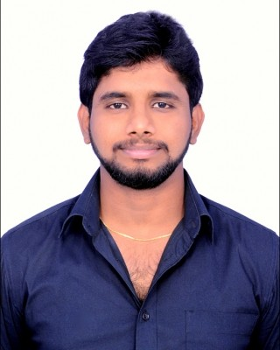
SRINATH
SRINATH.349730@2freemail.com

PROFILE

Sales professional with a proven track record in retail medical sales. Passionate to grow, develop and excel in the field, using excellent sales and assertiveness skills.
Objective – Willing to work as a player in challenging and creative environment & wish to apply my entire potential whole heartedly

LIFE HEALTH CARE GROUP,DUBAI
WORK EXPERIENCE
PHARMA EXECUTIVE

10-02-2015 — 26-09-2016

Worked as pharmacy executive in LIFE HEALTH CARE GROUP for 1 Year 8 months. ROLES & RESPONSIBILITIES:
-To ensure proper merchandising, managing the pharmacy inventory and expiries, handling insurance prescriptions.
-Handled nutraceuticals and sports nutrition.
-To ensure consistent maintenance & growth in daily sales by strictly implementing the sales strategies as instructed.
-To ensure right customer service

NUTRI SYNAPZZ THERAPEUTIX PVT LTD
MEDICAL REPRESENTATIVE ROLES AND RESPONSIBILITIES:
-To find an opportunity by visiting pharmacist

JUNE 2013 — DECEMBER 2014

-To visit the specialty doctors regularly as per the campaign planner.
-Effective communication and demanding for the prescriptions
-To ensure product availability in the nearest pharmacy
-Follow up for the prescriptions
-To implement the strategies as instructed by the company
-To analyze the weekly secondary & primary sales
-To keep an eagle eye on competitors so as to update on competitor knowledge
-To ensure target is reached & consistent growth every month as per the business plan given.

QUALIFICATIONS 1.UAE driving licence is in progress to get it soon.(Final Road Test)
- Qualified as a Registered Pharmacist in TAMILNADU PHARMACY COUNCIL with

- Completed the Graduation in Bachelor Of Pharmacy at SRM UNIVERSITY in the year of May 2013 with 86.085 Aggregate.

EDUCATION Bachelor of Pharmacy AUG-2009 — MAY-2013
SRM UNIVERSITY
Completed the Graduation in Bachelor Of Pharmacy at SRM UNIVERSITY in the year of May 2013 with 86.08%
ACADEMIC PROJECT PROFILE:
Project: Fibrinolytic and Anti-Thrombolytic Action on blood Using HYGROPHILA AURICULATA.
Project Role: Project leader.

Board of Intermediate Education JUNE-2007 — MARCH-2009
Sri Krishna Chaitanya Junior College Sri Krishna Chaitanya Junior College
Completed the Board of Intermediate Education at Krishna Chaitanya Junior College in the year of March 2009 with 91.3%

INTERESTS Watching movies, Reading books, photography, playing carom, cricket, video games, facing challenging tasks.

SKILLS -Good written and verbal communication.
-Ability to build good customer relations.
-Leadership skills & interpersonal skills, versatile, committed and dedicated to work.
-Knowledge of anatomy physiology and pharmacology, current treatment options, In- clinic activities, forecasting weekly sales analysis.

DECLARATION I hereby declare that, above information is true to the best of my knowledge & nothing has been concealed herein. All the documents shall be produced as and when required.

