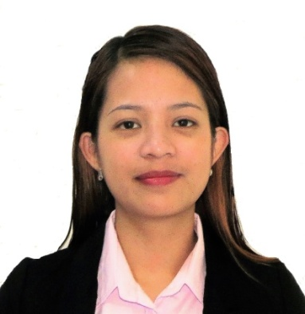

JOY
JOY.349758@2freemail.com

OBJECTIVE
---------------------------------------------------------------------------------------------------------------------
Secure a position that will enable me to use my strong communication and organizational skills, customer service background and my ability to work well with people.

WORK EXPERIENCES
---------------------------------------------------------------------------------------------------------------------
CUSTOMER SERVICE REPRESENTATIVE
Sitel Philippines Incorporation,
US Credit Card Account - CapitalOne Bank
February 2015 - January 2017

Handle customer inquiries, complaints, billing questions and payment extension or service requests about their credit card account. Calm angry callers, repair trust, locate resources for problem resolution and design best-option solutions.

Key Accomplishments:
- Officially commended for initiative, enthusiasm, patience, persuasiveness, intense customer focus and dependability in performance evaluations.
- Presented and promote company products and services to present and potential clients.
- Completed voluntary customer service training to learn ways to enhance customer satisfaction and improve productivity.

OFFICE STUDENT ASSISTANT
College of Nursing, University of the Cordilleras
June 2012 – January 2015

Handle student’s and staff’s inquiries. Store, organize and manages files. Answers phone calls, takes memos, type, edit and proofread documents.

Assist with event planning and implementation, ensure office equipment is properly maintained and serviced, monitor and maintain office supplies, perform work related errands as requested such as going to the post office and bank and keep office area clean and tidy.
SKILLS
---------------------------------------------------------------------------------------------------------------------
- Excellent English Communication Skill
- Typing Skill – 60 words per minute
- Multi-tasking Skill
- Organizational Skill
- Good Listening Skill
- Adaptable and have the ability to work under pressure
- Strong analytical and problem-solving skill
- Computer Literate- MS Word, MS Outlook, MS Excel, MS Access, MS PowerPoint

EDUCATION
---------------------------------------------------------------------------------------------------------------------
BACHELOR OF SCIENCE IN OFFICE ADMINISTRATION
University of the Cordilleras
Baguio City, Philippines
June 2012 – August 2015

HIGH SCHOOL GRADUATE
Benguet National High School
Benguet, Philippines
June 2008-April 2012

AWARDS
---------------------------------------------------------------------------------------------------------------------CUMLAUDE, College Scholar & Dean’s Lister

PERSONAL DATA
---------------------------------------------------------------------------------------------------------------------
Nationality: Filipino
Status: Single
Language Spoken: English and Filipino
Gender: Female
Date of Birth: December 02, 1995
Height: 152 cm
Weight: 50 kg

REFERENCES: Available upon request.

