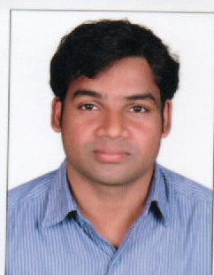

RESUME
VIMAL
VIMAL.349779@2freemail.com

accountant
- 6 years of experience in accounting including 1 year experience in the UAE.
- Very good experience in manual and computerized accounting.
- CPA+ certified

Key Skills

- Good communication skill in both English and hindi.  - Good experience in MS. Office | - Good experience in both manual and computerized accounting.  - Willingness to work hard.
Professional Experience

Crayon stationary LLC, abudhabi, uae.
Accountant / sales man, December/2015 to till date
Key Responsibilities :
- Prepare profit/loss statements and monthly closing and cost accounting reports.
- Compile and analyze financial information to prepare entries to accounts such as general ledger accounts.
- Preparing Sales Entry
- Purchase Invoice Entry
- General Ledger Entry
- Prepare and review budget, revenue expenses, payroll entries invoice and other documents’.
- Cost estimation

Professional Experience (continued)

VICTORY ATC Trissur, Kerala, India.
Assistant Accountant & Admin, April 2010 to November 2015

Worked and assistant account and in office administration
Key Responsibilities:

- Preparing Sales Entry
- Purchase Invoice Entry
- General Ledger Entry
- Preparing invoices
- Assisting chief accountant
- Petty cash handling
- Maintaining a systematic filing system
- Stationary maintenance.
- Assisting all other administration works

Education & Certifications

- KERALA, CALICUT UNIVERSITY - INDIA
Bachelor OF COMMERCE (B.com)

- Kerala, BOARD OF VOCATIONAL HIGHER SECONDARY (VHSE) — INDIA

TRAINIG AND SHORT TERM COURSES

CPA+ (certified professional accountant).
Quick Books, DAC EASY, PEACH TREE, TALLY ERP9.
MS Office (Word, Excel, PowerPoint,)

Computer Skills:
- MS Office (Word, Excel, PowerPoint, Access, Outlook)
- Open Office Tools.

Declaration:

I, hereby declare that the above mentioned information’s are true to the best of my knowledge and belief.

