Accountant, B.Com graduate

VIVEK
VIVEK.349827@2freemail.com

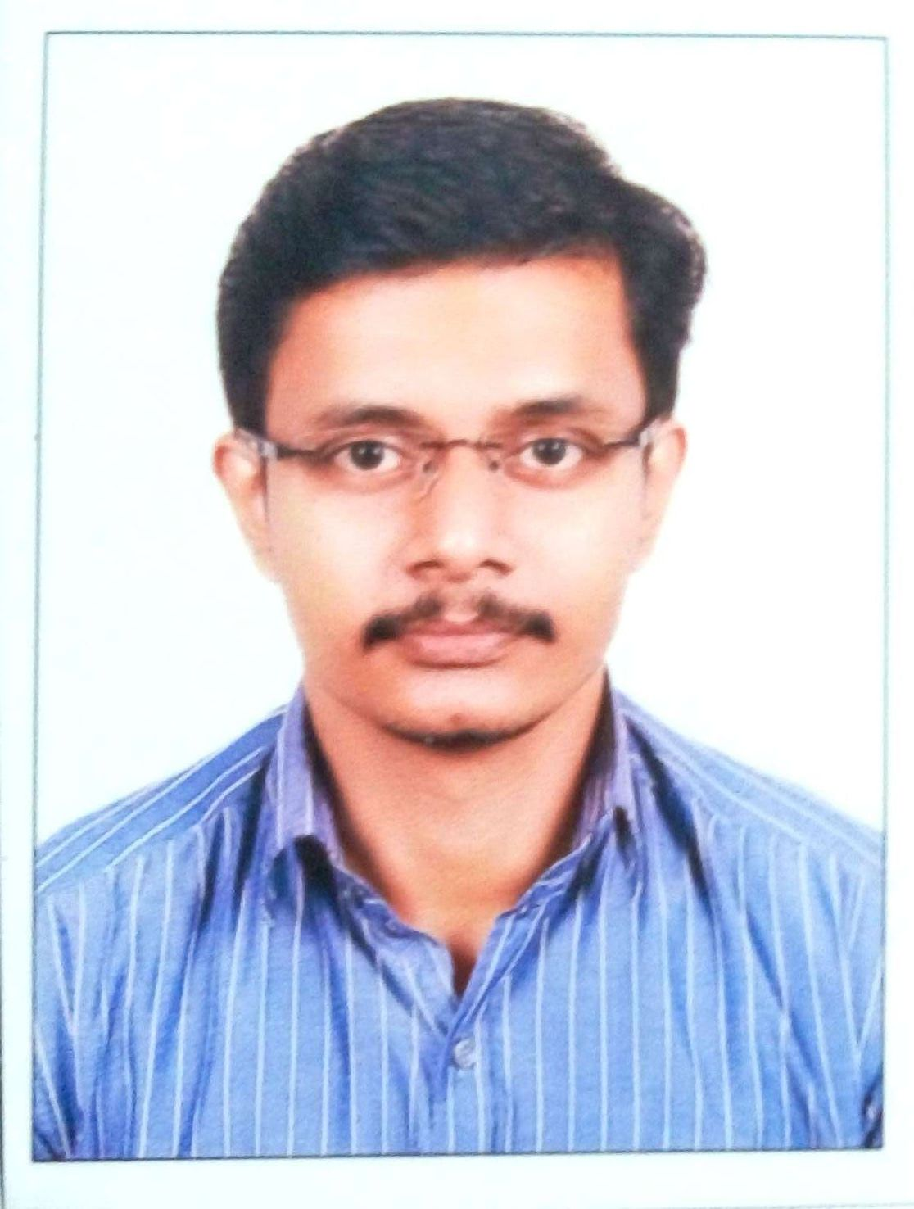
OBJECTIVE
To be an active participant in growth of an organization contributing to its all-round development with my best efforts and that provides me superior training in enhancing my knowledge and accelerated pathway in my future growth along with the growth of the organization.
KEYSKILL SUMMARY
- Accounts Payable  - Procure to Pay  - Provisions  - Oracle R12,11i  - Quick Learner  - Leadership | - GL Reconciliation  - Bank Reconciliation  - Budgeting  - Problem Solving skills | - Auditing  - Purchase  - Tally ERP 9  - Adaptability  - MS office
PROFESSIONAL SYNOPSIS
- Quess Corp Limited - Facility Executive
  - Worked with TATA Consultancy Services Limited Kochi under contract
from 01-Oct-2015 to 15-Feb-2017.
  - Successful implementation of tracking system to ensure timely
payments within credit period resulting in high credibility among
vendors.
  - Proven efficiency in successful closure of PNCs lower to market
rates.
  - Implemented first-check point before initiating invoices in system
resulting in high accuracy in invoice processing & time saving for
various departments.
  - Timely release of purchase orders thus by meeting the purchase
needs within short period, lower to normal periods.
- Genius Consultants Limited - Finance associate -Accounts Payable
  - Worked with TATA Consultancy Services Limited Kochi under contract
from 01-Feb-2014 to 30-Sep-2015.
  - High appreciation from senior management for timely & accurate
processing of payable bills.
  - Implemented an efficient secondary level checking system for
payable bills.
  - Proven skills in checking, processing and follow ups resulting in a
confidence as reliable employee.
  - Efficiency in meeting deadlines during month & year-end closing.

- Paragon Polymer Products Pvt Limited - Assistant Accountant
  - Worked from 08-Jan-2013 to 08-Jan-2014.
  - Implemented efficient and time saving system in dispatch sessionthus by improving the efficiency of staffs & billing department andconsiderable reduction in stock mismatch.
  - Efficient handling of cash, stock & various Government department related matters.
  - Independent handling of branch matters resulting in appreciation from top management.
- Rangamani & Company, Chartered Accountants
  - Worked from 01-Jan-2011 to 31-Jan-2012.
  - Started as audit assistant, promoted to Assistant manager (Audit & Admin) post replacing Qualified Chartered Accountant on his resignation.
  - Appreciation on implementing work hierarchy that benefitted on accurate tracking of files under processing and the level of completion.
  - Client appreciation for implementing efficient internal controls in their firm.
  - Scheduling Auditing & other works for Article assistant & other staffs and managing the day to day work of the firm and reporting to the Partner.
EDUCATIONAL QUALIFICATION
COURSE | UNIVERSITY/BOARD | YEAR OF PASSING | PERCENTAGE OBTAINED
CA-CPT | INSTITIUTE OF CHARTERED ACCOUNTANTS OF INDIA | 2010 | 66%
BCom | MAHATMA GANDHI UNIVERSITY | 2009 | 74%
PLUS TWO | BOARD OF HIGHER SECONDARY EDUCATION, KERALA | 2006 | 88%
SSLC | BOARD OF PUBLIC EXAMINATIONS, KERALA | 2004 | 84.5%
DECLARATION
I hereby put forward my candidature for your kind consideration with the declaration that the information furnished above is true, complete and correct to the best of my knowledge and belief. Place : Dubai
Date :

