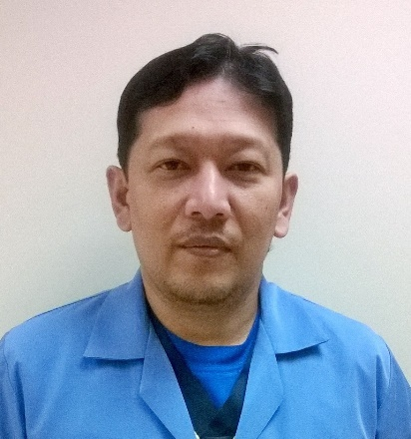

Rogelio

Rogelio.349865@2freemail.com

JOB SUMMARY

At the clinical direction of Radiologist /Chief Technologist and the Administrative direction of the Radiology Manager., Performed CT Scan, General Radiography and other modalities in the dept. without a minimum supervision.

QUALIFICATION

ASSOCIATE IN RADIOLOGIC TECHNOLOGIST (PASS THE PHILIPPINE BOARD EXAM)
SAUDI COMMISSION FOR HEALTH SPECIALTIES (PASS THE SAUDI COUNCIL EXAM)

WORK HISTORY

2008-2017 PROCARE RIAYA HOSPITAL
Al – Khobar K.S.A
X-Ray / CT Technologist

- Perform CT, General Radiography, C-Arm, Fluoroscopy and BMD
- Assist Radiologist in Ultrasound procedure
- Review medical records, patient history and pertinent information before taking any procedures.
- Explain procedure and position according to the protocol
- Select proper technique/protocol to obtain data, scan and evaluate images and send to PACS.
- Provide patient care comfort, safety, and patient confidentiality.
- Demonstrate competency with the use of all applicable aspect of RIS, PACS.
- Perform on call duties and/or work variable shifts as assigned to meet departmental needs.
- Perform related duties as assigned.

2008-2004 DANIEL O. MERCADO MEDICAL CENTER
Tanauan City Batangas, Philippines
Radiologic Technologist

- Officer in charge and Radiation Safety of Radiology dept.
- Plans, develops, coordinates and supervises all activities within the radiology department.
- Plans, develops and supervise in service training programs for all staff, and other personnel in areas pertaining to radiology.
- Consults with other professional personnel in furthering the integration and support of radiology services.
- Develops reporting procedures and forms for use within the Department and for relaying pertinent radiology data to medical, nursing and other professional personnel.
- Coordinates inter-departmental meetings.
- Manages departmental recruiting, disciplinary problems, evaluation and other employee relation problems.
- Develops, maintains and evaluates budgets, equipment and other program needs.
- Perform CT and General Radiography in the Department.
- Performs related duties as required.

1995-2004 SANTO TOMAS GENERAL HOSPITAL
San Roque Sto Tomas Batangas
X-Ray Technologist

- Perform general radiography such as Skull, PNS, Cervical ,Shoulder, Chest Abdomen, Pelvis, Upper Extremities and Lower Extremities.
- Perform special procedures such as Barium Enema, Upper GI series, Small Intestinal Series, T-tube cholangiogram, Intravenous Pyelography, Urethrogram and Hysterogram.
- Prepares and position patients using care tact, courtesy and patience.
- Prepare and assist Radiologist in all ultrasound procedures.
- Perform other related duties such as process x-ray films, maintain records of x-rays taken, stocks and supply.

EDUCATION

2003 – Radiation safety Officers in Medical Radiography
Certified by the Department Of Health, Manila.

1993 – Pass as an X-ray Technologist
Philippine Regulatory Commission

1992 – Associate in Radiologic Technologist
Lyceum of Batangas, Capitol Site, Batangas City
LICENCES AND CERTIFICATE

2010 – INFECTION CONTROL LINK
PROCARE RIAYA HOSPITAL
Al – Khobar K.S.A.

2009 – CENTRICITY RIS CORE MODULES:
PROCARE RIAYA HOSPITAL
Al – Khobar K.S.A.

2009 – COMPUTED RADIOGRAPHY APPLICATION
PROCARE RIAYA HOSPITAL
Al – Khobar K.S.A.

2009 – SAUDI COMMISSION FOR HEALTH SPECIALTIES
DAMMAM. K.S.A

2016 – BCLS PROVIDER
DR.FAKHRY & AL RAJHI HOSPITAL
Al – Khobar K.S.A

REFERENCES: Available upon request.

I certify that all the information provided on this resume is true and correct.

