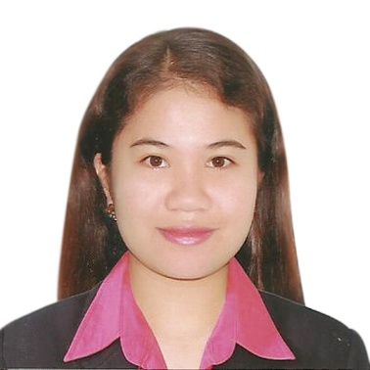
RIZALYN
RIZALYN.349898@2freemail.com

CAREER OBJECTIVE___________________________________________________________

Seeking for a challenging responsible growth oriented position where my classification and experience can be effectively utilized and share for the benefit and advancement of the company.

QUALIFICATIONS _______________________________________________________________

EDUCATIONAL BACKGROUND

COLLEGE:

B.S. in Customs Administration
Philippine Nautical and
Technological College
Dasmariñas, Cavite, Philippines
SY 2009-2013

HIGH & GRADE SCHOOL:

Altavas National Highschool
SY 1999-2008
Altavas, Aklan, Philippines

CERTIFICATION

Chamber of Customs Brokers Inc.
Good Standing
2016

Customs Broker Licensing
Philippines Regulatory Commission
2013

PERSONAL DATA

AGE : 25
NATIONALITY : Filipino
CIVIL STATUS : Single
RELIGION : Catholic
HEIGHT : 5’3”
WEIGHT : 54 kgs.

- Proficiency in all areas of Microsoft Office: Excel, Word and PowerPoint
- Good in oral and written English communication
- Good team player and goal oriented problem solver
- Member of Philippine Customs Brokers Society

EMPLOYMENT HISTORY______________________________________________________ ___

Import Break-Bulk Assistant Documentation/ Assistant Billing
Mercury Freight International Inc.
Paranaque City, Philippines
August 06, 2013 – September 24, 2015

Responsibilities:
- Compute local charges, update monthly reports
- Monitors shipping arrival and delivery
- Endorsed bill of lading copy and delivery orders

Customs Declarant
Explorer Freight Corporation
Paranaque City, Philippines
December 1, 2015 - December 31, 2016

Responsibilities:
- Compute duties and taxes, prepare necessary documents
- Monitor shipments, notify consignee of status through emails and calls
- Supervise customs representative in regards with shipments processing

TRAININGS & SEMINARS_____________________________________________________________
PNTC Leadership Training
Tagaytay City, Cavite Philippines
September 3, 2011

Pro- Active Customer Service
Paranaque city, Philippines
November 10, 2016

REFERENCES__________________________________________________________________

AvailabIe upon request.

I hereby certify that the above are true to the best of my knowledge.

