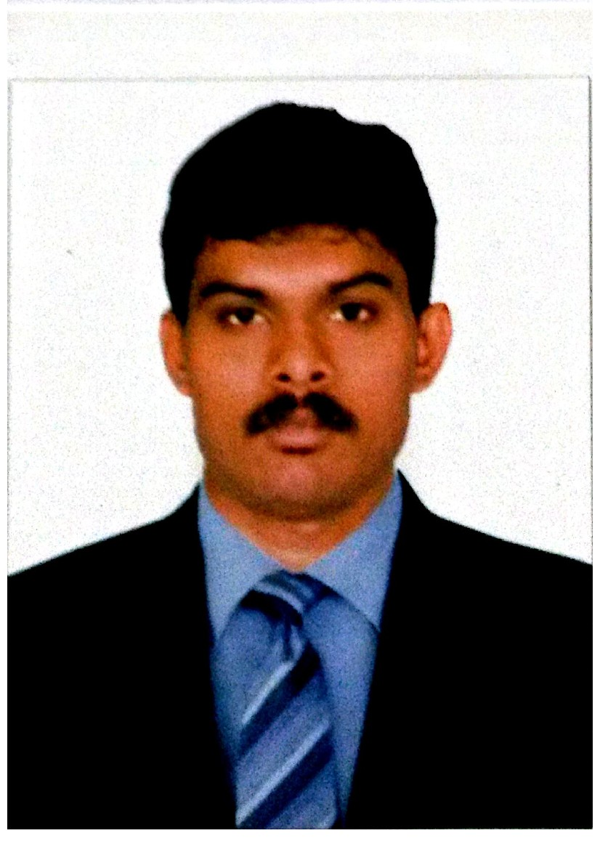
Bathuza
DOB 10/02/1985
Civil Engineer
Overseas Experience: 8 yrs
Driving Licence Issued: Oman

Mobile : C/o 0501685421| e-Mail : bathuza.349907@2freemail.com

Sales Engineer / Procurement Engineer

My career planning:
Obtain a position that will enable me to use my strong sales skills, marketing background and abilities to work well with people.

WORKED IN : UAE, KENYA, INDIA and OMAN

WORK EXPERIENCE:

- October 2013 - July 2016: Sales Engineer | Outdoor sales | Al Rahmani Building Materials Co LLC | Muscat, Sultanate Of Oman.

- January 2012 - September 2013: Sales Engineer | Outdoor sales | Pacific Building Materials Company (Part of Al Rahmani Group of Company) | Bangalore,India

- April 2011 - December 2011 : Sales Engineer | Counter sales | Al Rahmani Kenya LTD | Nairobi,Kenya

- March 2010 - March 2011: Sales Engineer | Counter sales | Al Rahmani Building materials Co LLC | Dubai and Ras Al Khaimah, U.A.E

RESPONSIBLE:

For Selling and promoting company products

DUTIES:

Making Construction site visit to meet Engineers / Site Managers on the first contact to introducing and explaining ourself and getting appointment with their purchasers respectively

Getting to know the customers buying pattern and listening to a customer’s needs

Preparing sales order forms and reports

Working Closely with delivery team to deliver the materials on time.

Submitting Invoice with delivery orders in their Accounts dept immediately once the Materials has delivered

Making phone calls to schedule meetings with potential customers
Increasing sale of products with existing customers

KEY SKILLS:

Strong understanding of Construction materials products and application

Providing Personalised solutions to a customers need

Keen knowledge in Interior and exterior products as well as Hardware and plumping

- May 2008 - March 2010: Site Engineer | Al Rahmani Group of Company| Dubai, U.A.E

Conduct surveys and then analyse them as well as maps, reports and other data pertaining to the area where construction is scheduled to occur.
Test all the building materials for use in specific projects, such as blocks, steel, concrete and accessories.
Consider and analyse the risk associated with each stage of the construction process and proceed accordingly

Project: Motor City Development, Dubai U.A.E

Nature of Contract: Sub contract | Main Contractor: Nasa Multiplex

Type Of the Job: Supply and Installation of Super structure.

Consultant: Edara | Client: Union Properties

EDUCATION QUALIFICATION:

2005 | Diploma in Civil Engineering | 67% |Government Polytechnic College
Tuticorin, India

2002 | HSC | 68% | TVANHSS| Vilathikulam, India

2000 | SSLC |85% | GHSS | Vilathikulam, India

PERSONAL INFORMATION:

Driving Licence: Valied Oman licence

Languages Known: English, Tamil, Malayalam and Hindi

OTHER INFORMATION:

Name: Bathuza

Nationality: Indian

Marital Status: Married

DECLARATION:

Finally, I request the concerned authorities to provide me a chance, so that I can prove the best of myself.

Bathuza

