Christopher.34
Christopher
Christopher.349910@2freemail.com

Graphic Designer

Dear Hiring Manager:

Perhaps you are currently in need of a talented Creative Graphic Designer / Production Coordinator and I am writing in response for the certain position advertised as being open at this time with your company. I am adept at carrying out a wide variety of design and development projects, and can readily conceptualized new ideas as needed. Now I would like to bring my talent & artistic flair to work for your company.

I have been involved in graphic design for more than 15 years, from advertising design, packaging design, exhibition desgin/displays, production or project management and final design implementations. Moreover my on the job experience has afforded me a well rounded skill set, including multi-tasking and communication abilities.

In addition to that I have a solid educational foundation and in my experience and personal qualities have a passion for design. I’m extremely enthusiastic about Modern Concepts and based on my knowledge I ensure that the quality of every submission meets high standards.

Greater details of my accomplishments and what i have to offer can be found on my CV.

.

Thank you so much for your time and consideration,

Christopher Mercado

HELL
this is my Curriculum Vitae

Description about me | fast-paced and pressured environment demonstrating strong analytical and problem
 | A highly self-motivated and goal-oriented person with over 15 years of experience in a
 | solving skills with computer proficiency: MS Office – Excel, Word, PowerPoint, Outlook,
 | plus Internet & Intranet, Adobe Photoshop, Adobe Illustrator, Adobe Indesign, Adobe
 | Flash, Adobe Dreamweaver, 3D Max.
 | Currently working in a company involved Graphic Designs, Advertising and Production.

My accomplishments

Below are events that I took part in and had accomplished, I had been part of graphic layouts and advertising and events production and coordination:
- HAAD poison prevention campaign event 16/ 11/2011

- SKMC orientation program event 24/4/2012

- Hard Wall restaurant interior renovation 3/10/2013

- 911 fire fighter challenge event 29/3/2016

- Al Ain hoarding and flags for national day 11/11/2014

- Al Firas Construction Consultant shell scheme kiosk event at ADNEC 7/12/204

- CAP exhibit stand event at ADNEC 8/1/2014

- Golden Sail restaurant interior renovation 8/10/2014

- Golden Health grand opening event 12/11/2015

- HAAD public health program event 15/11/2015

- CAP exhibition stand event at ADNEC 30/12/2015

- Eagle pest control shell scheme kiosk 30/12/2015

- Air swift office renovation with indoor signage 7/9/2016

Where i’m good at

Excellent IT skills, especially with design and photo-editing software
Adobe Photoshop |  |  |  |  |  | Adobe Dreamweaver
Adobe Illustrator |  |  |  |  |  |  | 3D Max
Adobe Indesign |  |  |  |  |  | CorelDraw
Adobe Flash
- Proficient in quality work and out of the box thinking / keen eye for colors

- Creative, Innovative, Showing great attention to detail, very careful and precise, Able to take criticism

- Brainstorming and developing new concepts / ideas to boost the brand

- Photography / Freehand Drawing

Where i’ve worked

Pixels Advertising LLC, Abu Dhabi - UAE
January 1, 2011 - March 15, 2017

Senior Designer & Production Coordinator

• Working with clients, briefing and advising them with regard to design style,

format, print production and timescales

• Developing concepts, graphics and layouts for product illustrations, company logos,

and event production

• Determining size and arrangement of illustrative material and copy, and font style and size

• Preparing rough drafts of material based on an agreed brief

• Reviewing final layouts and suggesting improvements if required

• Liaising with external printers on a regular basis to ensure deadlines are met and

material is printed to the highest quality.

 | • Handles creative designs / Lay-outs
 | • Handles production / Events / Exhibit Stands
 | • Corporate branding logo
 | • Re-touching photos
 | • 3D exhibit stands
 | • 3D signage’s / Build up / Flex / Neons / Pylons
 | • Banners / Hoardings / Outdoor Flags
 | • Annual Report / Brochures / Leaflets / Poster
 | • Letterhead / Business Card / Envelope
 | • Packaging design
 | • Acrylic design / Brochure stand / Gift box / Product standee
 | • Vinyl sticker design / Car wrapping / Gift items / Safety sign
 | Unigraf Advertising, Dubai Investment Park, Dubai - UAE
 | February 18, 2008 - December 15, 2009
 | Senior Graphic Designer & Operator
 | Obeid Advertising, Riyadh, Kingdom of Saudi Arabia
 | October 15, 2004 - December 4, 2006
 | Junior Graphic Designer & Operator
 | Maya Advertising, Sucat, Muntinlupa City Philippines
 | March 31, 1998 - October 13, 2004
 | Junior Graphic Designer
 | Tip Top Printing Press, Pasig City, Philippines
 | September 15, 1997 - March 15, 1998
 | Junior Graphic Designer
Handles machines | HP 5500 in-door inkjet
 | Jeti 3318, 5024 outdoor Large Format Printer
 | Seiko Painter W-64s
 | Mimaki CG130 fx cutter plotter
 | Roland Camm cutter plotter
Where i’ve studied | Major in Advertising @ Philippine Womens University
 | Bachelor of Fine Arts
 | 1993 - 1997
 | Taft Avenue, Manila, Philippines
 | High School @ Saint Rita College
 | 1989 - 1993
 | Dr. A Santos Avenue Paranaque, Manila, Philippines

Thank You

Graphic Design
PORT FOLIO

Christopher Mercado

Graphic Design
PORT FOLIO

Christopher Mercado
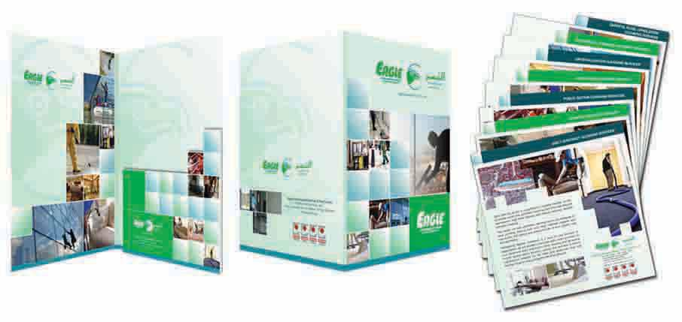

Folder & Leaflets

1

Graphic Design
PORT FOLIO

Christopher Mercado
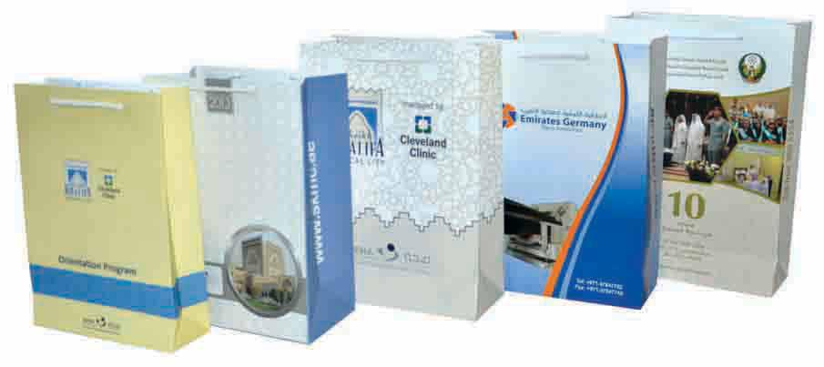

Corporate Paper Bag

2

Graphic Design
PORT FOLIO

Christopher Mercado
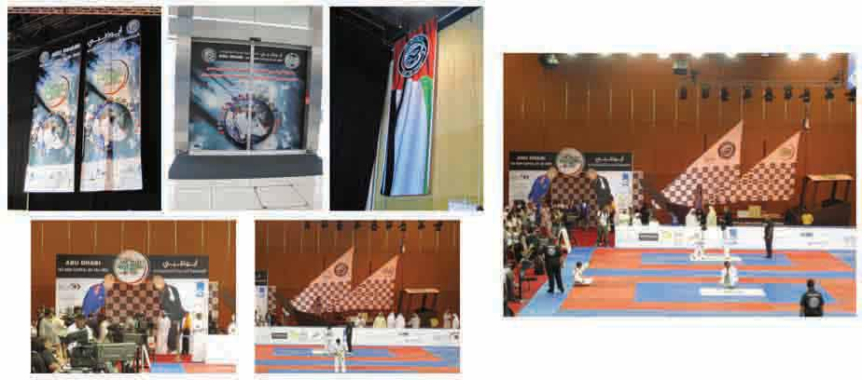

Jiu Jetsu Event

4

Graphic Design
PORT FOLIO

Christopher Mercado
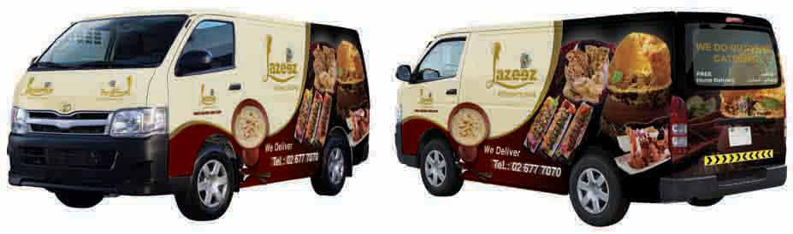

Car Wrapping

5

Graphic Design
PORT FOLIO

Christopher Mercado
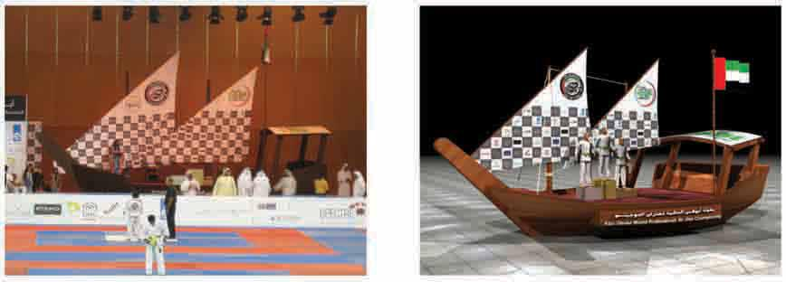

3D Max/Production

6

Graphic Design
PORT FOLIO

Christopher Mercado
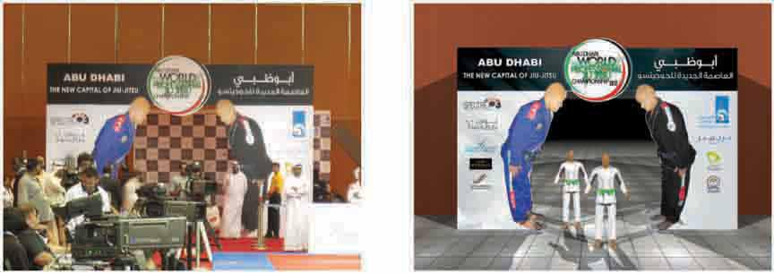

3D Max/Production

7

Graphic Design
PORT FOLIO

Christopher Mercado
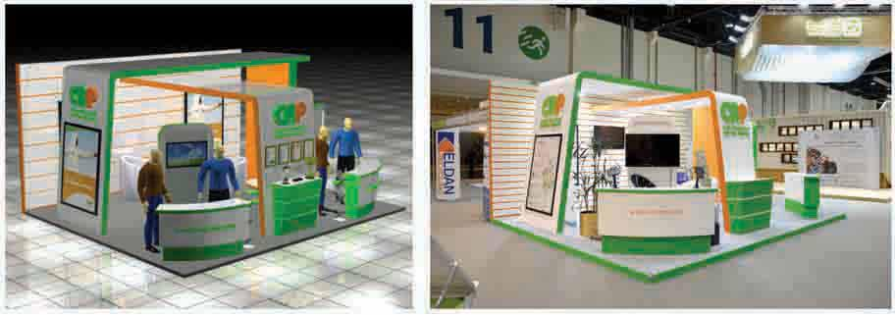

3D Max/Production

8

Graphic Design
PORT FOLIO

Christopher Mercado
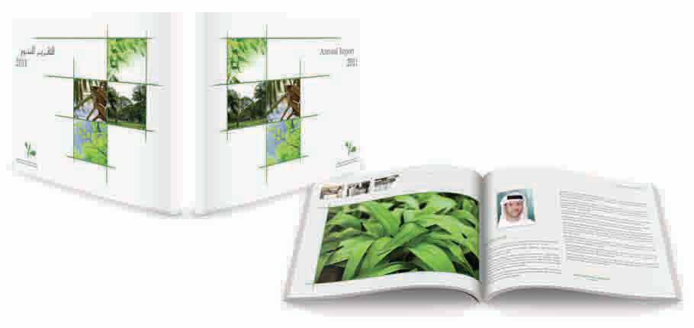

Annual Report

10

Graphic Design
PORT FOLIO

Christopher Mercado
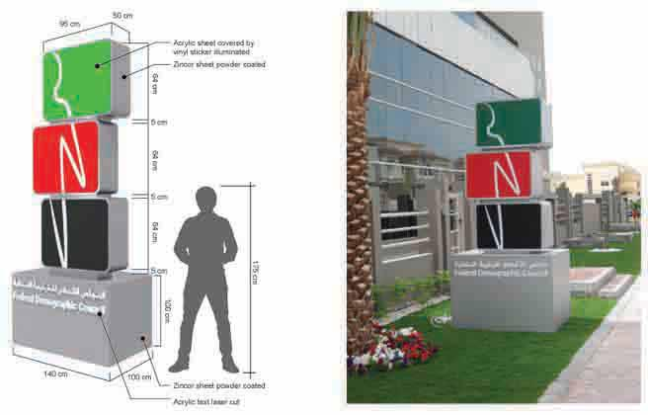

Pylon

12

Graphic Design
PORT FOLIO

Christopher Mercado
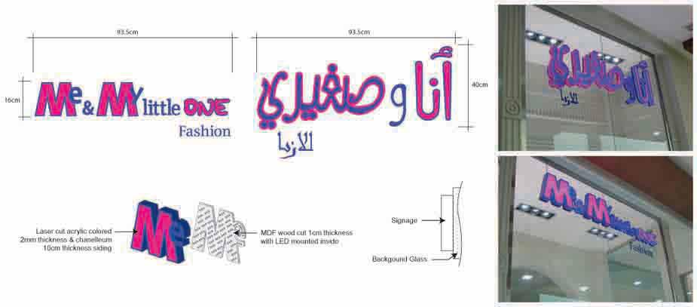

Lighted Signage

13

Graphic Design
PORT FOLIO

Christopher Mercado
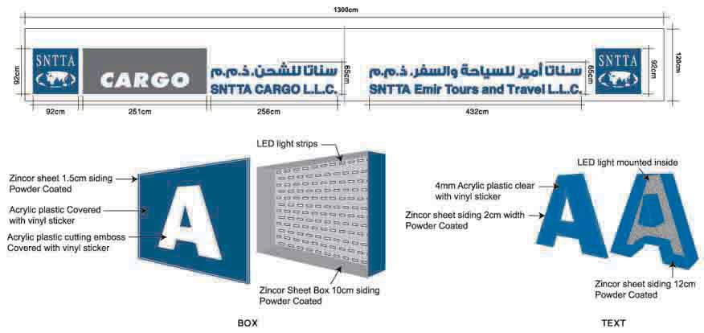

Lighted Signage

14

