PERSONAL SUMMARY:

Server Administrator
System administrator with MCSA certified having experience in managing server infrastructures and data - centre operations across Unix, Linux and Windows platforms. Effectively plan, install, configure and optimize IT infrastructures to achieve high availability and performance.

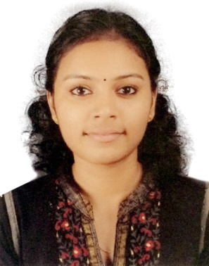
Jesetha
Jesetha.349943@2freemail.com
*Technical Skills

Personal Information:-
D.O.B | 15/Feb/91
Gender | Female
Nationality | Indian
Mar.Status | Married(Hindu)
Languages | English,  Malayalam& Hindi
Visa Status | Resident Visa  lasts on 05 Feb 2020
Dri.License | Indian D/L Holder

- Operating Systems Linux, Windows
- Linux Webservers, Mailserver, DNS, Firewall,FTP.
- Webserver IIS7,Apache
- Mail server Exim, Mail enable, Smarter mail
- Firewall IPTables and CSF.
- DNS Bind and MicrosoftDNS.
- Database MySQL,MSSQL.
- Control Panel Plesk, cPanel, WHM, SolusVM, Virtualizor.
- Virtualization OpenVZ, Xen, KVM, HyperV

Professional Experience
Activelobby Information Systems Pvt. Ltd , Kerala,India
Server administrator August’14 – october’2016

Activelobby is a well-established company in the technical support and remote infrastructure management industry providing 24*7 service to webhosting companies, data centers and internet service providers and corporate

- Analysing windows, Linux logs and troubleshooting system issues.
- Installation, configuring and troubleshooting web servers(Apache,IIS).
- Analysing website performance and optimizing the performance.
- Upgrade and update of server and server-software.
- Optimizing and Troubleshooting Database servers- MySQL and MSSQL.
- Managing disk quotas.
- Securing the server using Windows firewall, CSF and IPTables.
- Managing tuning and troubleshooting web servers.
- Maintaining backup of system state data and recovering using recovery tools.
- Regularly monitoring the server for performance analysis and suspicious activities.
- Integrating servers with control panel installed.
- Migration of server data from remote server using migration tools and manual migration.

Specialization

- MicrosoftCertifications:MicrosoftCertifiedSolutionsAssociate (Certification:Windows Server 2012)

- Microsoft Certified Professional
(Certification:Microsoft Certified Professional)

- Completed Course on Red Hat Certified Engineer

Education & Certifications

kerala, cochin University — INDIA
* Btch- computer science and technology (2010-2014)

Kerala, cbse — INDIA
* All India Senior School CERTIFICATE EXAMINATION (AISSCE) (2008-2009)

All India Secondary School EDUCATION (AISSE)
* Central Board Of Secondary EDUCATION, 2006 - 2007)

academic projects

Academic Project“THRESHOLD CRYPTOGRAPHY BASED SECURE ACCESS CONTROL FOR EMR IN AN ICU"

Academic mini Project“Smart Court”

Main seminar on“Matrix Based Android UI Development”

Declaration:-

I hereby declare that all the information given above are true and correct with the best of my knowledge and I bear the responsibility of the above-mentioned particulars.

