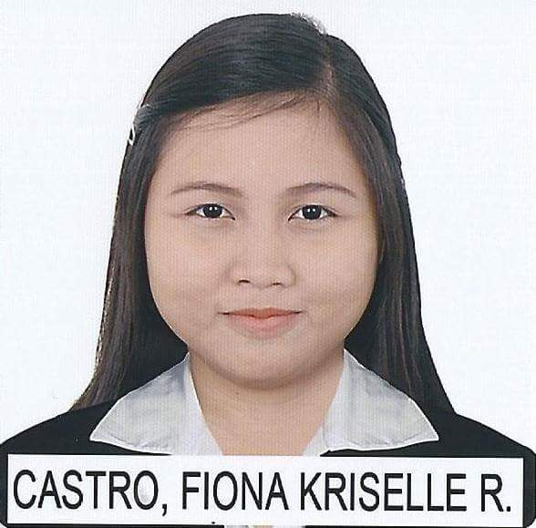
FIONA
FIONA.349945@2freemail.com

CAREER OBJECTIVE
BS in Accountancy graduate with good academic standing applying for an accounting position where I can use my knowledge and experience to ensure the delivery of all financial and accounting activities, while gaining knowledge of new skills and expertise

PERSONAL SKILLS
- Organized and efficient
- Highly honors company ethics and confidentiality
- Willingness to learn and adapt to changes
- Ability to work independently or as part of a team
- Competent, flexible and dedicated

TECHNICAL SKILLS
- Fully knowledgeable in general accounting, payroll, receivables, journal entry preparation and cost accounting
- Comprehensive understanding of fundamental tasks, such as paycheck calculations, taxation principles, preparing ledgers and journals
- Analyze financial data and prepare financial reports/statements
- Basic knowledge of related automated financial and accounting software systems (Bloomberg and Peachtree accounting)
- Proficiency in the use of various applications and programs including MS Office Suite (Word, Excel, and PowerPoint) and the Internet

EDUCATION
Bachelor of Science in Accountancy (2016)
Divine Word College of Laoag
Laoag City, Philippines
(Dean’s Lister for 4 semesters – being a candidate for cum laude unfortunately disqualified due to unofficial dropping of nonacademic subject)

ACHIEVEMENTS AND QUALIFICATIONS
- Civil Service Exam-Professional Level Passer (May 2015)
- Bookkeeping NCIII Holder (July 2015)
- Certified Financial Markets Professional (CFMP) (April 2016)

WORK EXPERIENCE
Payroll Accountant
DMMV Farms, Inc.
Brgy. Nangguyudan, PaoayIlocos Norte, Philippines
April 2016 - December 2016
- Maintains and updates employee information
- Calculates and verifies salary based on number of working days rendered by employee
- Ensure the appropriate disbursement of funds correctly and delivered on time
- Prepare payroll reports
- Documents all compensation activities

Bookkeeper / Teller
Western Union
Brgy.16 Blas Cid St. Laoag City, Ilocos Norte, Philippines
February 2015 – March 2016
- Records business transactions
- Files receipt and disbursement transactions
- Reconciles account by using cash transactions
- In charge with cash withdrawal

PROFESSIONAL DEVELOPMENT
Bloomberg Professional Service Training Program
East West Educational Specialists | Northwestern University | April 16, 2016

“JPIA: Life is here”
14th Regional Midyear Convention | Hotel Supreme, Baguio City | September 29, 2015

“Career Guidance 101”
14th Regional Midyear Convention | Hotel Supreme, Baguio City | September 28, 2015

“Convergence: Revitalizing Future Business TycoonsTowards the Corporate World”
SBA Annual Convention | Divine Word College of Laoag | January 26-30, 2015

“Dynamism of Future Business Professionals”
SBA Annual Convention | Divine Word College of Laoag | December 13, 2013

PERSONAL DETAILS
Nationality: Filipino
Date of birth: July 27, 1995
Marital Status: Single
Visa status: Tourist

REFERENCES
Will be provided upon request

