TEJIN

TEJIN.349988@2freemail.com

OBJECTIVE: 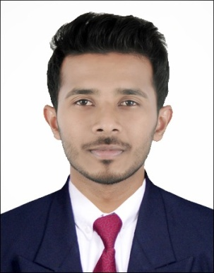

To achieve professional excellence with intellectual abilities, which gives me scope to apply knowledge and skills in comprehensive engineering that dynamically work towards growth of organization.

PROFESSIONAL EXPERIENCE:

JALANIDHI PROJECT.
(WorldBank aided Drinking Water and Sanitation Project of Kerala Government, in Edavaka Grama Panchayath)
- Designation:Senior Engineer.
- Duration: June 2015 – 17th February 2017.

ROLE AND RESPONSIBILITY:

- Oversee and coordinates assigned engineering wing.
- Planning of project.
- Preparation of plans,designs and estimation of high rise concrete tanks.
- Analyze, implement and review the structures, design plans and drawings.
- Preparation of documentation for regulatory approvals and contract issues.
- Obtain Administrative and Technical sanction.
- Preparationof plans and estimates.
- Directs work assignments.
- Site inspection.
- Quantity and quality analysis.
- Social mobilization.
- Inviting and evaluation of quotations/tender for work.
- Report Making and mailing to concern departments.
- Final inspection report preparation.
- Co-ordinate with third party inspection.

EDUCATIONAL QUALIFICATION:

- B.E –Civil Engineering,Anna UniversityChennai, Tamil Nadu -2011-2015 (Passed with 64.9%)
- HSC-Computer Science, Board of Higher Secondary Examination, Kerala-2011 (Passed with 71%)
- SSLC-Board of Public Examination, Kerala -2009 (Passed with 75%)

AREA OF INTERESTED:
- Building Constructions.
- Oil & Gas Constructions.
- Water & Power Structures.
- Construction management.
- Geo Technical.
- Environmental.

PROFFESIONAL ABRIDGEMENT:

- Motivated, self-starter with a passion to succeed and desire to excellence.
- A team player and an effective communicator with excellent leadership, and organizational abilities.
- Creative and New Ideas.
- Good communication and Interpersonal skills.
- Leading a good working culture.
- Manage any situation with suitable solution.

PROJECT:

- Pre final year project on “Planning,Designing and Estimation of IT PARK”.
- Final year project on “An Experimental Study on Concrete with Partial Replacement of Fine Aggregate by Using Marble Powder.

COMPUTER PROFICIENCY:
- AutoCAD.
- Well versed in Windows-98, Windows XP, Windows 7, and Windows 8.
- Proficiency in entire MS-Office.
- Good understanding of Internet tools.

TRAININGS:

- Industrial visit to METTUR DAM.
- Went industrial visit to CHETTINAD CEMENT FACTORY at Karur.

DECLARATION:

I hereby declare that all the information furnished above is true to the best of my knowledge.

