BEENA
Beena.349999@2freemail.com
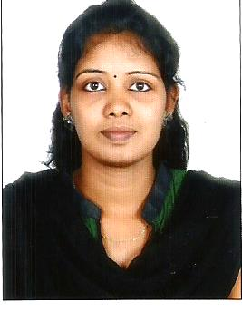
CAREER OBJECTIVE:

To obtain a position in the Human Resources and Administration field which allows me to apply my HR and Administration Experience, and utilize my exceptional people skills.

CAREER SUMMARY:

- A competent professional with 3.5 years of experience in the entire gamut of HR and Administration field.
- Adept at hiring all levels of Employees in Shipping and Logistic field.
- Lining up interviews and conducting aptitude test for candidates.
- Handling regular HR & Admin functions.
- Possess excellent communications and interpersonal skills.

EMPLOYER:

Vivid Visions Trexim Pvt Ltd, Chennai - HR and Admin Assistant from Nov 2014 to Dec 2016.

Tagknot Consulting & Solutions, Chennai - Talent Acquisition Executive from May 2013 to Oct 2014.
Key Skills:
- Screening
- Selection
- Employee Relations
- Negotiation
- Administration
- Follow up

WORK EXPERIENCE:

Vivid Visions Trexim Pvt Ltd, Chennai (HR and Admin Assistant - Nov 2014 to Dec 2016)

Key Responsibilities Handled:
- Responsible for Recruitment and Assisting Administration Activities.
- Responsible for Sourcing, Screening, Preliminary data collection to candidates. Selecting the right candidate for the specific role.
- Conducting interview of the candidates and selecting suitable candidates for the requirement.
- Handle the queries give briefing & finally shortlist the candidate.
- Maintaining the candidate database for future reference.
- Assisting to Admin Executive and coordinate for updating all Employees Database.
- Maintaining the Attendance Records of the Contract Employees.
- Maintaining Employee Performance Details.
- Keeping records of Visiting Cards, Printing of Stationary.
- Handling complete Facilities and infra structure of office.

Tagknot Consulting & Solutions, Chennai (Talent Acquisition Executive - May 2013 to Oct 2014)

Key Responsibilities Handled:
- Sourcing of quality profiles for various IT, Non IT & ITes.
- Responsible for managing the Full recruitment life cycle from understanding the requirement and furnishing them with relevant profiles.
- Identify candidates using different sourcing methodologies like referrals, Job search portals, and internal database and web postings.
- Should be able to build strong referral networks.
- Handled IT & Non IT Clients.
- Maintaining Profile Database.
- Following up with candidates till they are on-board.

ACADEMIC CREDENCIALS:

M.B.A. Human Resource : Bharathiyar University, Coimbatore, (2012)

B.A Lit (English) : Manonmaniam Sundaranar University, Triunelveli, (2009)
HSC : Higher Secondary, State Board of India, (2005)

SSLC : Secondary school, State Board of India, (2002)

Technical Skills:

MS Office

