CURRICULUM VITAE

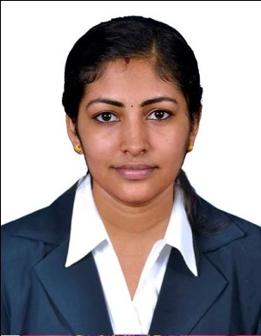 Ashlin
Ashlin.350018@2freemail.com

SUMMARY: Experience in Administrative and Telemarketing.

OBJECTIVE:

To secure suitable position requiring utilization of my knowledge, skill & experience in contributing towards the company‘s growth & objectives to work with dedication, devotion loyally to the company. Simultaneously also grow with the organization by securing more knowledge.

Strengths
+ Excellent Customer Service Orientation + High Level Analysis & Solutions Implementation
+ Team Spirit & Leadership Capabilities + High Sense of Commitment &Responsibility

EDUCATIONAL QUALIFICATION

- Currently pursuing MBA in HR from Annamalai University .( distance education )

- B.Com with Computer application from Mahatma Gandhi University, Aquinas College Kerala,

- Plus 2 (Commerce ) from Kerala board of Higher Secondary, St Sebastian H.SS Kerala, India

- 10 From Kerala board of High school, Fatima Girls H.SS Kerala, India

COMPUTER KNOWLEDGE

- Worked Windows (7, Vista, XP & 98),
- Internet MS Office, Excel

PROFESSIONAL EXPERIENCE

- Worked with Indus motors as Admin and telemarketing.

KEY RESPONSIBILITIES
- Updating enquiry status to relevant departments.
- Coordinating between customers, sales executives and relevant department heads.
- Preparingreports on daily enquiry status, phone calls, complaints and mailing to respective managers.
- Explaining the product or service to potential customers.
- Handling customer questions
- Scheduling appointments for sales staff to meet prospective customers
- Answering telephone calls from potential customers who are responding to advertisements.
- Recording enquiry details of new customers including reaction to the product or service offered.
- Making outbound calls with target.
- Maintaining and developing positive business relations with key personnel involved in business activity.

PERSONAL STRENGHTS:

- Punctuality and strong determination to succeed.
- Disciplined, dedicated, hardworking, energetic and organized.
- Ability to adopt new environment and grasp work quickly.
- Realistic and positive approach towards work and ability to work as a team.
- Ability to deal with people dramatically.

HOBBIES & PERSONAL SKILLS

- Music ( active participation in school levels )

- Dance ( achievements in youth festival competitions state levels )

- Pencil Drawing, craft making, fashion designing.

Declaration:
I hereby declare that the above-mentioned information is correct up to my knowledge and I bear the responsibility for the correctness of the above-mentioned particulars.

