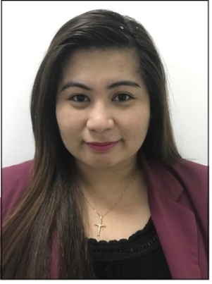
TIFFANY
TIFFANY.350023@2freemail.com

Objectives:
For international cultural exposure and hands-on experience as a gateway to a meaningful career. To develop my management skills, be an asset to the company and be a part of the company’s growth, to be globally competitive and effective individual.
Academic Qualification:
Institution name: Systems Technology Institute College (STI-College)
Location: J.Catolico Ave. General Santos City, Philippine
Graduation Date: April 2012
Field of Study: Bachelor of Science in Hotel and Restaurant Management

Work Experience:
Secretary/Receptionist
June 14 2013-February 2017
Thumbay Hospital – Ajman (Former GMC Hospital & Research Centre)
P.O Box 4184, Ajman – United Arab Emirates
Job Description:
Receiving the patients in reception, giving appointments via phone call and personal, Responsible for making the schedules of the doctors (duty roster, Academic works, meeting, & etc), Responsible for typing medical reports for insurance approval and patient’s request, dealing with patient’s complaints.

Customer Service Representative
Billing and Sales for AT&T U-verse
April 2012-March 2013
Sutherland Global Services
Jacinto Ext. Davao City, Philippines
Job Description:
Dealing with the account holders of AT&T U-verse (USA based company), responsible explaining monthly bill, processing payment thru credit/debit card, introducing new products of the company and selling mobile phones and data plans.

Certificates:

April 2012 Berlitz Passer (English Proficiency Exam)

Personal Details:
Date of Birth: 04 September 1991
Age: 25 years old
Gender: Female
Marital Status: Single
Country of Citizenship: Filipino
Language: Filipino (Tagalog), English (Advance)

I hereby certify that the above information is true and correct to the best of my knowledge and belief.

