CURRICULUM VITAE

MOHAMMMED.350071@2freemail.com
NAME: MOHAMMMED Automation/Electrical/Electronic Engineer
Personal Profile:  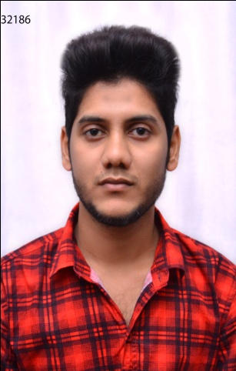  Personal Data:  Date of Birth :12/11/1992  Gender : Male  Marital Status : Single Nationality : Indian  Languages Known:  English  Urdu  Hindi  Kannada  Personal Interests:  - Playing cricket, Football.  - Listening Music.  - Outing with family and friends.  Personal Strengths:  - Good understanding ability.  - Good communication skills.  - Ability to deal with people diplomatically.  - Adaptable to any environment. | curriculum vitae outline:  Automation/Electrical/Electronics Engineer  - Type of Employment wanted: Full Time  Career Objective & Summary:  Completed B.E Degree in Electrical & Electronic Engineering from VDRIT Further, pursued certification in PLC, SCADA, DCS, HMI, AC Drive & ROBOT from OTPTC Pune,India.  Seeking a good career and holding a responsible position in the reputed organization and ensure credible performance to work towards exceeding the set goals contributes for the organization.  Academics:  - S.S.L.C Passed(2009) From Karnataka ,India.  - PUC Passed From Board of Higher Secondary Examination(2009-2011) Karnataka ,India.  - Bachelor of Engineering(BE) in Electrical And Electronics Engineering(EEE) Passed From VTU Belgaum,Karnataka ,India.  Final Year Project:  - Economical design of solar street light of VDRITcampus HALIYAL :Collected solar radiation by pyrano meter of 12 months and then calculated solar minimum radiation and annual radiation.(Bachelor of Engineering)  Computer / Technical Skills:  - MS Office.  - Operating Systems: Windows XP, Windows Vista and Linux.  - Internet And Email  EXPERIENCE:  Worked as an Automation Application Engineer for six months in ACS(Automation And Control System) OTPTC Pune-411026, Maharashtra India.

Hands On Experience:  PLC Programming:  - Using Relay Logics, Ladder Logics (LD).  - Timer,Counter Configuration and  Instructions Sets  DCS  PNEUMATIC & HYDRAULIC  LABVIEW  PLC Interfacing:  - MMI  - SCADA  - VFD  ABB ROBOT:  - Robot Studio  HMI: Beijer:  - E-Terminal  - DELTA  PLC WIRING:  - IO CONFIGURATION  - VFD WIRING  - PANEL WARING  - MCC PANEL | SCADA(Supervisory Control And Data Acquisition):  - Elipse : Elipse SCADA  - Rockwell: RS View32  - Wonderware: Intoch  PLC(Programmable Logic Controllers)  - SIEMENS:-Model: Simatic S7 200  Software: Step 7 v.5.3  - ALLEN BRADLEY:-Model: Micrologix 1000  Software: RS Logix 500  - MITSUBISHI:-Model: FX  Software: Melsoft Series GX Developer  - MESSUNG:-Model: NEXGEN 2000PLUS  Software: Codesys v.2.3.9.7  - DELTA:-WPL SOFT  - L&T:- LX SOFT  - HONEYWEL:-SOFTMASTER  - GIC:- GX SOFT  duties and responsibilities  •Organize and provide documents, reports and  information to department and external clients in  an useful and well-organized manner.  • Plan meetings and conference calls and arrange  and manage meetings.  • Initiate purchase requisitions.  • Order office supplies and equipment.  • Solid understanding of computer programming and software development.  • Creative thinking skills.  • Detail-oriented personality.  • Excellent manual dexterity.  • Ability to communicate well to other members of the development team.  • Plan and organize meetings and events.  Declaration:  I hereby declare that the above information is true and correct to the best of my knowledge.

