CURRICULAM VITA 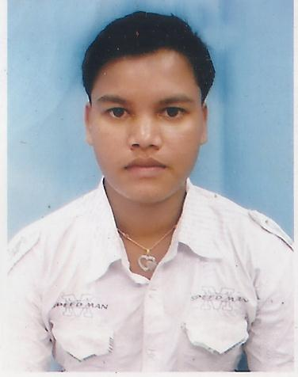

PRASHANTA
PRASHANTA.350098@2freemail.com

ACADMIC QUALIFICATION:
- H.S.C Passed from B.S.E .Orissa in the year2008 with53% Marks.
TECHNICAL QUALIFICATION:
- I.T.I Passed with trade ELECTRICIAN from BALASORE TECHNICAL SCHOOL,BALASORE in the year 2010 with90%.
- Diploma passed in Electrical Engineering from SSB REGIONAL INSTITUTE OF SCIENCE & TECHNOLOGY,MAYURBHANJ,ODISHA in Nove,2013 .
WORK EXPERIENCE
- 1 Year in Purnima Engineering & Construction in production
- 1 Year in CEAT TYRE in production
IT SKILLS
- Continue ASSOCIATE in JK TYRE
- Basic Knowledge of Computer for word ,excel & internet.
- ADMMA(Advance Diploma Machine Maintenance & Automation) for Machine maintenance, Mould Manufacturing, Electrical Hardware Control System, Electrical Machine, Basic Electronics Control, Pneumatics and Hydraulics System. PLC, SCADA & HMI, TIA Portal, AUTOCAD Electrical, Project Work.
STRENGH
- Positive attitude, Strong determination, Willingness to learn.

PERSONAL DETAIL’
Date of birth 05/06/1993
Sex: Male
Caste: OBC
Nationality: Indian
Religion: Hindu
Language Known: Hindi, English, Odia, Bengali
HOBBY: Playing & watching cricket, study .
ABOUT ME
Having faith on god &my self .I am self confident person with good character ,has hard determination and very responsible for challenging task to achieve organization goal with in the time .
DECLARATION

I here by declare that the above statement are true and correct in my best knowledge and

