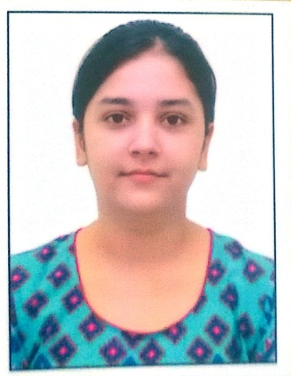
Name: Iram
Iram.350173@2freemail.com
Objective: To find a job as teacher that will enable me to acquire and develop the skills required for a career in teaching.
Profile: An outgoing and articulate graduate .
Education and qualification:
*2016 - B.com from Punjab university
*2013 - +2 in commerce from CBSE board.
*2011 - 10th from CBSE board.
*IELTS with 6.5 bands.
Work experience:
1 year experience in kindergarten.
Skills: good communication skills in English, Hindi & Punjabi.
Can read Urdu and Arabic.
Interests: accounting, teaching, debating & counseling.

