CURRICULUM VITAE
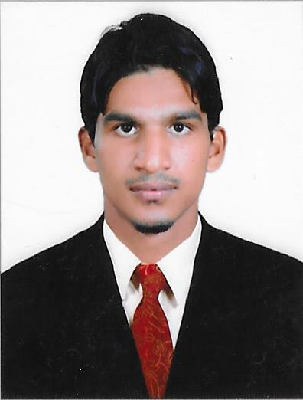

Ahammed
Ahammed.350268@2freemail.com

CAREER OBJECTIVE

I would like to broaden my experience by taking a challenging assignment, which would enable me to exercise my communication, organizational and administration skills in an effective manner. Looking for a career that offers innovation and challenge, I like to work in an environment that offers room for both personal and professional growth.

AREAS OF EXPERTISE

- Computers and Administration: Proficiencies include MS Office, Basic in (MS Vision, IOS, Android Systems, Adobe Photoshop, apple and Windows Operating systems).
- Easily making good working relationships.
- Networking of Operating systems.
- Outstanding time-management and organizational abilities to provide exceptional staff support.
- Communication and Presentation: Exceptional interpersonal skills, handles sensitive matters.

EXPERIENCE HIGHLIGHTS

- Worked at Al Dawaween Typing & Photocopying Services at Bur Dubai –Dubai, UAE (from July 4, 2014 to August 31, 2016) Typist cum Clerk.

Duties & Responsibilities:
- Strong phone contact handling skills and active listening
- Translating Arabic, English, Urdu and Malayalam Documents, E-mail, Fax, Photo copying, and printing.
- Preparing letters, memos, quotations, forms contracts, and other types of Correspondence for the officials as requested.
- Issue invoices to customers.
- Update customer files with issued invoices.
- Attending phone calls.
- Preparing documents such as contracts, leasing agreements and closing
statements.
- Arranging and evaluating all applications and documents to be submitted to the police and courts.
- Lodging labor complaints and absconding reports.
- Drafting letters, email correspondences and documents both in English & Arabic
- Maintaining and ensuring the staff daily attendance register.
- Preparing Monthly report for to the Manager.
- Maintaining Employees Personal Accounts and their Personnel Records
- Handling Labour and Immigration application forms and related works.
- Other office administrative duties for growth and development.

EDUCATION

- BA (English Literature)
UNIVERSITY OF CALICUT – Calicut – Kerala
Enthusiastically pursued university’s Bachelor of Arts, Obtained education in English Literature.

- Graduation in Islamic Studies and Human Science, English, Urdu and Arabic Languages.
Malik Deenar Islamic Academy affiliated to Darul Huda Islamic University

IT Skills: MS Office, Internet Applications, Basic in (MS Vision, Web designing, Adobe Photoshop)

KEY SKILLS AND COMPETENCIES

- Having a mathematical mind with good analytical skills.
- Customer relationship
- Able to prioritize individual workloads according to deadlines.
- Confident attitude with a proactive approach to work.
- Able to work as part of a team or alone.
- Good relationship maintenance approach with customers and employees.

LANGUAGE SKILLS

- Arabic
- English
- Urdu
- Hindi
- Malayalam

PERSONAL DETAILS

Date of Birth : 14th August 1990
Religion : Muslim
Nationality : Indian
Marital Status : Single

DECLARATION

I hereby declare that the details furnished are true to the best of my knowledge and belief. If given me an opportunity I assure you of discharging my abilities and duty sincerity up to your satisfaction.

Looking forward to work with your esteemed organization and awaiting for your valuable response

~ References available upon request~

