Application for the Post of Medical coding
CURRICULAMVITAE
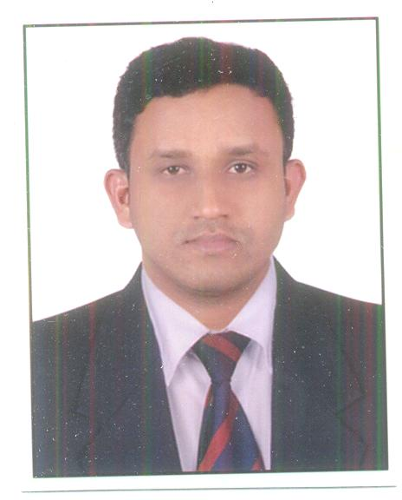
SAJAN
SAJAN.350272@2freemail.com
Personal Data
Date of Birth : 18.10.1988
Age : 28years
Gender : Male
Nationality : Indian
Marital status : Single
Religion : Christian

OBJECTIVE:
To obtain a challenging and growth oriented position with my knowledge, experience and rise to eminence by utilizing my talents with dedication, determination and sincerity seeking challenging career with compensative atmosphere to enrich my career.
Educational Qualification:
- Certified Professional Coder® (CPC)

Membership ID: 01288710
- ICD 10 CM Proficiency Assessment
- BSc in Nursing(RGUHS)
- HSE- Govt of
Kerala
- SSLC Govt of Kerla
Membership:
Life membership at Karnataka stateNursing Council
Membership
Core competence:
- Strong Medical Background.
- Strong analytical skill and reasoning ability.
- Ability to grasp and learn new concepts quickly.
- Excellent communication skills.
- Ability to work in a demanding rigorous, and
exhilarating team environment.
- Good inter personal skills.
- Ability to work under tight schedule
- Ability to work in a team or individually.

PROFESSIONAL EXPERIENCE:
1)Prime Care Medical Center,Abu dhabi
21 MAR 2015 To Present
Nature & responsibility of work :
Submission and resubmission of various insurance claims. Currently we are dealing with 21 insurance companies Like Daman,ADNIC,Nextcare,NAS,ALICO,SAICO,OMAN etc.
Accurately assign ICD-9-CM and CPT code and sequence diagnosis and procedures per patient medical records, utilizing company software and input information in to computerized patient record system

2) Omega Healthcare Pvt Ltd, Bangalore
10FEB 2013 to JAN 05 2015
Nature & responsibility of work :
- Medical coder Evaluation and managment (E/M).
- Accurately assign ICD-9-CM ,ICD 10 CM and CPT code and sequence diagnosis and procedures per patient medical records, utilizing company software and input information in to computerized patient record system.
- Maintained 99% of accuracy and productive quality.
- Achieving more than Target every day, consistently with a Productivity & quality.
- Maintaining the Complete Track of Client Information as knowledge documents.
- Meeting the client SLA.
- Share the workload of other team members whenever it's high with to meet the teams daily Production.
- Interacting with Clients, Attending the client Calls and client meeting
- Maintaining the Complete Track of Client Information as knowledge documents

Technical skills:
- Windows, MS Office, Excel, Open office, Photoshop & Internet.
- Worked in various Software (Citrix , 3M, A-life, Putty,)
Language known
- English
- Hindi
- Malayalm
- Tamil
I hereby Acknowledge that all the information provided above are true and accurate as per my knowledge.

