Curriculum Vitae
Mohammed
Mohammed.350345@2freemail.com
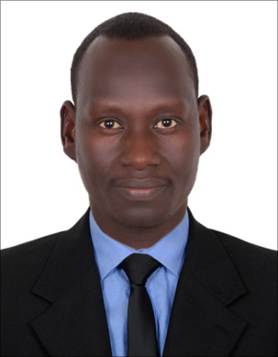
Name: Mohammed
Date of Birth: 1980 / 01 / 01
Gender: male
Nationality: Sudanese
Visa statues :- Employee
PERSONALSTATEMENT
An energetic, committed and fully qualified teacher who has a passion for teaching English, and a track record of excellence. During my work I gained vast experience of developing a student's knowledge, skills, and attitude. I possess the ability, skills and determination to make a real and significant difference to the lives of my students. As a superb communicator I more than able to establish a classroom atmosphere in which pupils are held accountable for their own behavior. Right now I am looking for a suitable teaching position, where passionate, bright and ambitious teachers can make a significant impact.
Employment to :
Ahmed Fadil Secondary School for Boys July 2013 – August 2016 - Sudan
English language teacher .
Responsible for assisting in the educational and social development of pupils under the direction and guidance of the head teacher. In charge organizing classes and responding to the strengths and needs of students during lessons.

Duties:
- Planning & delivering well-structured lessons which engage & motivate students.
- Planning and organizing visits, field studies and special activities connected with the teaching of the subject.

- Supporting the school in delivering the curriculum effectively.
- Managing resources effectively and ensuring appropriate value for money.
- Organizing and supporting a range of extra-curricular activities.
- Achieving and maintain high standards of care and education.
- Planning, preparing and reviewing the school curriculum with other staff.
- Ensuring all Health & Safety policies are implemented and adhered to at all times.
Al Hawata secondary school for boys
English language teacher April 2011 – 2013
Duties:
- Earned high marks for the quality and creativity of classroom teaching and lesson plans.
- Taught general education students as well as individuals with learning challenges and special needs within a mainstreamed, inclusive classroom.
- Actively served on a variety of school committees and task forces focused on curriculum development, textbook review.
- Established positive relationships with students, parents, fellow teachers and school administrators/staff.
Al Hawata commercial school for girls
English language teacher 2007 – 2011

Duties:
- Maintaining accurate daily attendance records.
- Promptly responding to inquiries from the parents of any pupils.
- Communicating and consulting with the parents of pupils.
- Safeguarding the health and safety of pupils whilst they are in the classroom.
- Participating in school extracurricular clubs and societies.
- Assisting trainee and junior teachers in their fulfilling their duties.
- Addressing all teaching problems and student shortcomings promptly and effectively.
- Marking and monitoring every student’s work and setting targets for future progress.
Education/Qualifications:
2002-2006 BA (Hons) in Arts and Humanities
University Of Juba
(graduating December 2006)
Department of English Language
Other qualifications and skills:
- Customer service and Customer Product sup port
- Exceptional listener and strong in communications skills
- Professional skills with honesty, diligent and integrity offer effective leadership skill and finest relationships with managers, supervisor, colleagues and clients.
- Enthusiastic employee who do well in various work environments
- High level analytical thinking in identifying, studying, improving work complex methods
- Innovative Problem Solver, Detail-oriented, Hardworking and Punctuality Skill

Skills:
- Languages-fluent Arabic, Excellent English
- Computer skill-good knowledge of standard software packages
Interests: Swimming, travel
References: Available on request
Employment to date : Orion Fire And Safety International LLC working as a computer operator and data entrance , September 2016 to date .

