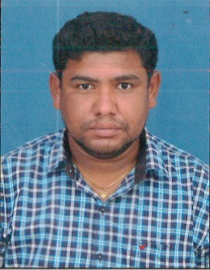
RESUME

SRIDHAR

SRIDHAR.350456@2freemail.com

CAREER OBJECTIVE
To obtain an entry level position in a reputed organization, where I can use my skills and abilities for the growth of the organization and where there are bright chances for the improvement of my career.

ACADEMIC PROFILE

- B.sc (2003-2006)
Institution : M.A.M.M.V.NDegreeCollege, Mancherial
University : KakatiyaUniversity
Specialization : B.sc (electronics)
Year of passing : 2006

COMPUTER PROFICIENCY

Operating system : MS-Dos, MS Windows
Office Automation : MS-office (Word, Excel, Powerpoint, Access)
PGDCA, C, C++, HTML

Work Profile

Company : Anjan Tours & Travels.

Designation: Assistant Travel Consultant.

- Promoting and marketing the business.
- Dealing with customer queries and complaints.
- Providing advice about visas or passports.
- Managing budgets.
- Maintaining statistical and financial records.
- Meeting profit or sales targets.
- Preparing promotional materials and displays.
- Keeping clients up to date with any changes.
- Dealing with complaints or refunds.

DECLARATION

I hereby declare that the information given above is true to the best of my knowledge. I swear that if I selected, I will abide by the service and conduct rules of the firm.

