Mohamed

Mohamed.350491@2freemail.com
Mechanical Engineer

Personal Profile

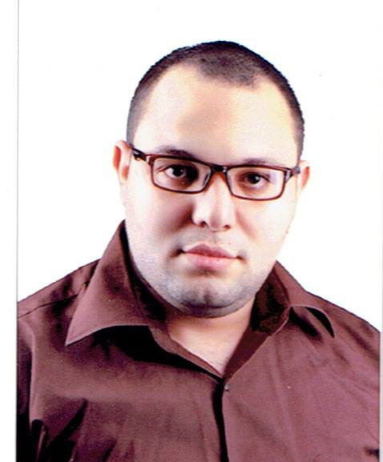

Achievements

- [graduation project][ Study process and laboratory for the static coefficient of friction]
- [ASNT LEVEL2 IN UT/RT/MT/PT/VT]
- [Prepare CWI Certified welding inspector]

Education

[From2009 – To2015] [Bachelor of Mechanical Engineering] [Zagazig University]
Grade achieved: [good]

[From2010 – To2010] [ICDL] [Zagazig University]
Grade achieved: [Excellent]

[From2011 – To2011] [Plc Advanced] [Jelecom Mansoura University]
Grade achieved: [good]

[From2015 – To2015] [Solid Works] [Jelecom Zagazig University]
Grade achieved: [Excellent]

[From2015 – To2015] [AutoCAD 2d] [Egyptian Engineers Union]
Grade achieved: [Excellent]

From[2016 – To2017] [ASNT LEVEL2]
[Quality Control Co]
Grade achieved: [CERTIFICATE In UT/RT/VT/PT/MT]

Work Experience

[From2013 – To2014] [production engineer] [Schuman company]

[From2014-2015] [mechanical engineer] [Fresh company]

Skills

Technical: .Well in English
.Well in computer

Interpersonal: The leadership of person and I can integrate and work in a group
I can work at night or during the day
I can work under pressure
I can work at different times and for long periods

