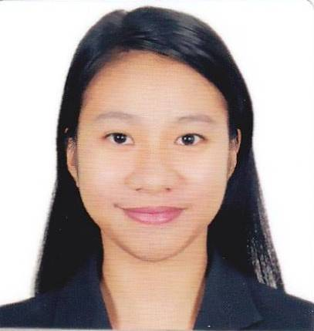
Abegail
Abegail.350553@2freemail.com
Registered Medical Technologist, MLS (ASCP^{i})^{CM}
HAAD Licensed

Objective: To apply what I learned in academic and training experience as well as to develop my skills in a respectable laboratory with an opportunity for developing my personal character and as a professional.

Personal Information:
Birthdate: August 26, 1993
Birthplace: Bagumbayan, Roxas, Oriental Mindoro
Citizenship: Filipino
Religion: Baptist
Language Spoken: English and Filipino
Civil Status: Single

Educational Background
Tertiary: Trinity University of Asia
Course: BS Medical Technology
Internship: Armed Forces of the Philippines Medical Center (V. Luna)
Year Graduated: April 2013

Secondary: San Mariano National High School
Year Graduated: March 2009

Elementary: Libertad Elementary School
Year Graduated: March 2005

Key Contributions:

- Performed clinical laboratory tests pertinent to chemistry, hematology, urinalysis (including other body fluids and fecalysis), microbiology, immunohematology and histopathology (routine tissue processing).
- Received and collected specimen for various routine tests.
- Followed the laboratory procedures for specimen handling and processing, test analysis, reporting and maintaining records of patient results.
- Had experienced using or operating laboratory equipment and machines.
- Complied with hospital policies related to laboratory safety, infection control and proper disposal of biohazard wastes.

Extracurricular involvement:

- Certified Member of the Philippine Society of Medical Technology Students (2009-2013)
- Certified Member of the Philippine Association of Medical Technologists (PAMET) (2015-2017)
- International Member of the American Society of Clinical Pathology
(ASCP) (2013-2017)

Seminars and trainings attended:

- Blood Banking Procedures (29th – 31st of July 2016)
- 13th Newborn Screening Convention: “Enhancing Newborn Care, Nurturing Minds, Brightening the Future and Saving Lives” (6th and 7th of October 2015)
- 3rd Continuing Professional Development Seminar for 2015 “Evaluation of Peripheral Blood Smear and Optimizing Hematology Reliability through Optical Technology (15th of September 2015)
- Orientation on Expanded Newborn Screening for Rizal Province
(10th of April 2015)
- Basic Orientation of Newborn Screening with Practicum on Heel Prick Method (24th of February 2015)
- Hematology Machine “Model: TEK 5000” (13th of June 2014)
- 2nd Continuing Professional Development (CPD) “Harmonizing Standards in Hematology” (27th of June 2014)
- Nationwide Blood Donation Activity in Celebration of the 77th AFP Anniversary (2012)
- Internship Enhancement Workshop on Interpersonal Relations and Values Management (2012)
- Phlebotomy seminar conducted by BD Diagnostics (2012)
- PHISMETS 4th Annual Student Congress at Manila Central University
Theme: Metamorphosis 2: HPO MT Objectives in High Power Objectives”
- Hematology Automation conducted by Sysmex (2011)
- Basic Life Support Training conducted by EMS (2011)

Experiences:

- Padre Pio Maternity and Medical Hospital November, 2014 – February, 2017
(Assistant Head)
- Chiombon-Panganiban Maternity July 2014 – October, 2014
and Medical Clinic
- St. Matthews Hospital (Reliever) February, 2014 – June, 2014
- Armed Forces of the Philippines September 2012 – March, 2013
Medical Center – V. Luna (Intern)

I hereby certify that the above information is true and correct to the best of my knowledge and belief.

