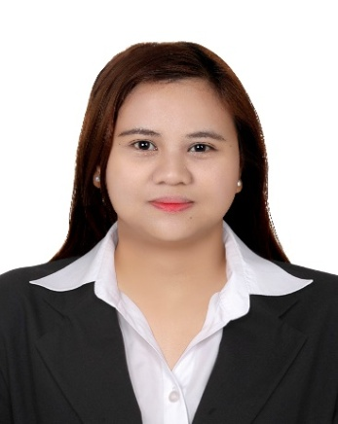
Marieta
Marieta.350628@2freemail.com
Bachelor of Science in Information Technology

Professional Objective: To use and continuously develop my skills to provide a better service and secure a position in a company related to my field of expertise.

WORK EXPERIENCE

Accounting Assistant 2
Universal Leaf Philippines Incorporation
Purok #07 NapaccuPequeño,ReinaMercedes,Isabela
April 2010-January 2017

Responsibilities:

- Preparing and Maintaining ORB reports for weekly and monthly to be given to BIR.
- Providing documents needed in shipping and transfer out of tobacco.
- Prepares and maintains the office schedule and appointments
- Provide administrative support for the daily business to the office
- Maintains the Office files and file correspondence and other records efficiently and accurately
- Drafting letters, documents, and e-mails
- Monitoring of daily activities in warehouse for future inventory
- Monitoring of Transfer out/in of Tobacco for the future inventory.
- Printing Guia and other documents needed for the local and international transfer out.
- Printing and Sorting Purchase Invoice Voucher of Farmers.
- Assisting an Accountant in tobacco inventory.
- Assisting an Accountant in Reconciliation
- Encoding data in Word, Excel and System.
- Substitute in absence of my co-worker.
- Telephone Operator
- Weigher of tobacco

EDUCATION AND AWARD

Tertiary Level
Isabela State University,Cauayan Campus
Bachelor of Science in Information Technology
2006-2010

Secondary Level
Cauayan National High School
Turayong,CauayanCity,Isabela
2001-2005

Primary Level
San Fermin Elementary School
San fermin,CauayanCity,Isabela
1996-2001

TRAININGS& SEMINARSATTENDED

Philippine Youth Congress in Information Technology (Y4IT)
University of the Philippines
Diliman, Quezon City
September 10, 2009

Junior Philippine Computer Society (JPCS)
Isabela State University Cauayan Campus
February 11, 2009

Red Cross of the Philippines
Universal Leaf of the Philippines Incorporation
Purok#07 NapaccuPequeño,ReinaMercedes,Isabela
August 26, 2016

ORGANIZATION
Junior Philippine Computer Society (JPCS)
2006-2010

Red Cross of the Phillipines
Bronze Member
August 26, 2016-August 2017

SKILLS & INTERESTS

- Honest
- Flexible
- Optimistic
- Good attention to details and can handle multi task
- Initiative with high level of energy and ability to work under pressure
- Proficient in installing PC hardware
- Good Communication Skill-verbal and written skills in English & Tagalog.
- Excellent in working Microsoft Excel, Outlook, Word, PowerPoint,
- Know Basic accounting
- Knowledge in Book keeping
- Knowledge in Inventory stocks/ Office supplies
- Knowledge in handling system
- Knowledge in operating system
- Knowledge in Joomla
- Ability to make decisions and take appropriate actions.
- Ability to meet schedules and deadlines of the work area.
- Trouble Shooting and Networking

