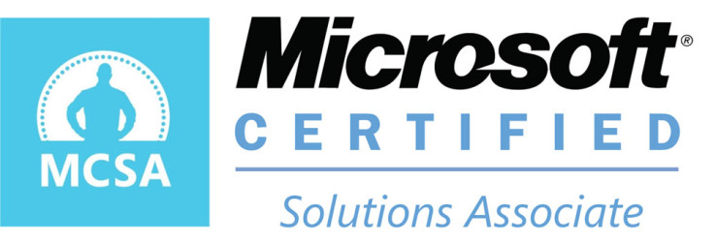
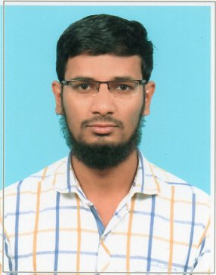
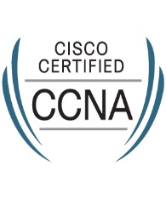
RESUME

IBRAHI
IBRAHI.350689@2freemail.com
PROFILE SUMMARY
Position Applied For | IT Desktop Support Engineer
Certifications | Bachelor of Engineering in Computer Science  CCNA  MCSA
Years of Experience | 2 Years
Nationality | Indian
Status | On Visit. Readily Available.

EDUCATION

Bachelor of Engineering (Computer Science)
University : Anna University, Chennai.
Batch : 2011 – 2014
CGPA : 5.89%

TRAINING & CERTIFICATIONS

- Completed Cisco Certified Network Administrator (CCNA).

- Completed Microsoft Certified Solutions Associate (MCSA) certified.

TECHNICAL KNOWLEDGE

- Windows XP / 7 / 8 / 10 Installation, Image Deployment & Configuration
- Windows 2012/2008, Server Installation & Configuration.
- PC Hardware, OS and Network Installation, configuration and troubleshooting.
- Assembling Computer & Notebook Hardware parts.
- Installing Operating systems, Software Applications.
- Installation, Configuring, and Troubleshooting of LAN.

WORK EXPERIENCE

Company : Care IT Solution Pvt.Ltd, Chennai.
Role : Desktop support
Type : Hardware and Software troubleshooting
Duration : From MAR-2015 to SEP-2016 (1 year 6 months)

Responsibilities

- Supporting Hardware, Network, Desktop Applications including MS Office, Outlook.
- Provide support to customers relating to hardware and software, computer applications and peripherals.
- Setting up shared folders, local & network printers and mapped drives
- Image/Re image Pcs & Laptops.
- User Profiles Backup and Restore
- TCP/IP Configuration
- Provide technical solutions and troubleshooting services on need basis.
- Provide support to remote users.
- Collect serial numbers and Perform Inventory Management of IT Assets.
- Cleaning infected PCs and installing Antivirus.
- Resolve Network related problems and troubleshooting of LAN Connectivity issues.
- Setup Internet access through wireless connection and configure Proxy settings.
- Basic Firewall configuration.
- Log incidents and attending routine calls at customer’s site.
- Install & Update Latest Service Packs, patches and antivirus updates
- Migration of Operating System from Windows XP to Windows 7/10.
- Scanner configuration & troubleshooting.

personal details

Nationality : Indian
Date of Birth : 15/04/1992
Gender : Male
Marital Status : Single
Languages : English, Tamil
Visa Status : Visit Visa - Valid until 6th May, 2016.

