Deepam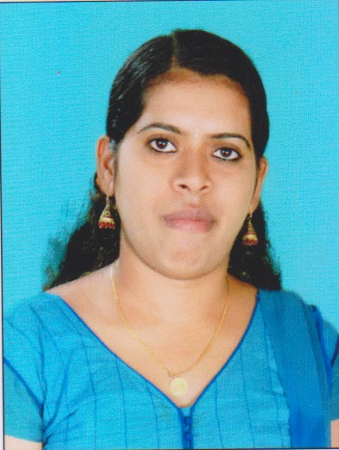
Deepam.350713@2freemail.com

OBJECTIVE

Seeking a challenging opportunity and growth oriented career to enhance my skills and to excel. Achieve greater heights in the career, through commitment, learning and significant contribution to the organization’s success.
CAREER SNAPSHOT

- Highly developed interpersonal skills.
- Multi-tasking with good concentration
- Self-motivated with the ability to coordinate daily office functions
- Knowledge of computer operation
- People Management skills.
- Positive Attitude
- Willing to learn functions and responsibilities
ACADEMIC PROFILE

- B.COM DEVAMATHA COLLEGE, PAISAKKARY, KANNUR UNIVERSITY
- PLUS TWO ST.SEBASTIANS H.S.S VELIMANAM
- S.S.L.C ST. THOMAS H.S KILIYANTHARA
TECHNICAL EXPERTISE

- Tally ERP in SREE SANKARACHARYA INSTITIUTION, IRITTY, Kannur (2013-2014)
- JCHNP’ (HARDWARE & NETWORKING COURSE) in JETKING INFO TRAIN, MYSORE (2007-2008)

EXPERIENCE

APPOLLO BGS HOSPITALS MYSORE, KARNATAKA, INDIA
Ward Secretary 16th December 2008 to 15th January 2010.
- Responsible for smooth functioning of the ward and effective coordination with unit.
- Scheduling appointments, billing patients and compiling and recording
- Checking inpatients files daily
- Duties of record keeping, maintaining stocks, keeping accounts and handling emergencies
- Maintaining discharge procedure and filing inpatients records and outpatients records in correct manner and submitting to MRD department
RELAINCE COMMUNICATION INFRA STRUCTURE, CHENNAI, INDIA
Customer Support Executive, Technical Support Executive 15th June 2010 to 2nd April 2013.

- Senior executive in complaint desk, technical support in technical Help desk.
- Giving new updates, providing feedback, also application training to new reps
- Resolving the customer queries and complaints for the pre paid customers
- Handling the escalation calls
- Working with a telecoms industry in service and resolving the customer queries.
SMART FASHION LLC ALAIN
Accountant Assistant
- PREPARE AND VERIFY DAILY REPORT
- PREPARE INCOME \ SALES DETAILS AN DEPOSITS
- PREPARE AUTHORIZED REFUND VOUCHERS
- UNDERTAKING CLERICAL TASKS SUCH AS FILING, BARCODING
- CALCULATING AND CHECKING ,AMOUNTS AND RECORDS ARE CORRECT
- MANAGING PETTY CASH TRANSACTIONS AND BOOK KEEPING

PERSONAL PROFILE

Date of Birth : 03/02/1987
Languages Known : English, Kannada and Malayalam Hindi & Tamil
Sex : Female
Marital status : Married
Nationality : Indian
Religion : Hindu

Hobbies : Listening Music

ABOUT MYSELF
As I believe HARD WORK is the key to SUCCESS and CHARACTER to PERSONALITY. I always keep myself Proactive, Industrious and Good-natured.

DECLARATION
I declare that the information and facts stated herein above are correct to the best of my knowledge and belief.

