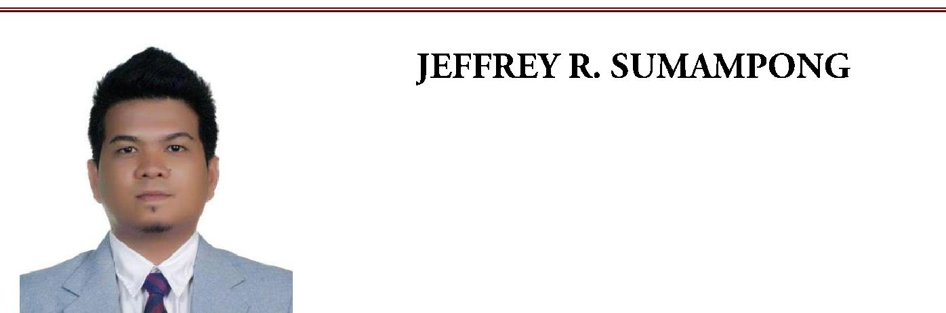

CIVIL/SITE ENGINEER / ESTIMATOR

E-mail add : Jeffrey-350739@2freemail.com

OBJECTIVE

To become an efficient employee in which the company can rely on.
To render my sincere service base on the potential that I have and will acquire, in achieving company’s mission and vision.

QUALIFICATION

Bachelor’s Degree in Civil Engineering

With (5) five years experience as Site Engineer, QA/QC Engineer, Estimator, Civil Supervisor, Service Engineer, & Site Supervisor in diversified projects from horizontal (Roads(Asphalt & Concrete paving), Gas pipe line trenching, Storm water line(RCP’s excavation & installation) to vertical (Panel board/Pipe slipper/Pipe rack foundation, Warehouse, Building & Villas).
Knowledgeable in Autocad (2D & 3D), Staad Pro v8i, Primavera P6, & MS Project. Computer literate, knows Microsoft Office application (Excel, Word, & Powerpoint) Initiative and resourceful with sense of urgency to finish the task.
Abillity to work under pressure with less supervision and can adopt changes for the continuous improvement for the benefit of the company.

PROFESSIONAL EXPERIENCES

QA/QC/SITE ENGINEER
Dec. 2015 – Dec. 2016

CS MICHAEL DEVELOPMENT CORP.
(Developer / Construction Company)

Unit 203, 2nd Flr. MIT Bldg., Gorordo Ave., Lahug Cebu City, Cebu, Philippines

Project Assignment

Pristine Grove Residences
Purok 2 San Jose, Talamban, Cebu City, Cebu, Philippines

Keiri Park Residences
Cadahuan, Talamban, Cebu City, Cebu, Philippines

Duties & Responsibilities

- Supervise & monitor daily manpower and site materials.
- Site supervision & decision making with the coordination of Project Manager.
- Project planning (Work scheduling, Materials procurement planning & Execution).
- Execute daily & weekly report for the updates of work progress & site concerns.

- Facilitate/Assess/Witness (QA/QC) Testings of sampled Materials (Rebars,Concrete,Soil).

- Secure request for inspection, conduct daily inspection on work progress, and punch listings.

- Ensuring that the punch lists were rectified with the coordination of site in charge before the final inspection.

- Materials quantifying (actual) for the remaining and additional works (work scheduling & Costing).

CIVIL SUPERVISOR / ESTIMATOR / QA/QC ENGINEER (CIVIL)
April 2013 – May 2015

REBAQ GEN. CONTRACTING EST.
(Human Resource Company)

Dammam, Saudi Arabia

Project Assignement

Qurrayah Independent Power Plant - Samsung Engineering (Sub-Contractor side)
Wasit Gas Project - Aramco Project under SK Engineering (Sub-contractor side)
Sadara Project - Fluor Corporation (Sub-Contractor side)
Kemya - Sabic Project under Daelim Engineering (Sub-Contractor side)

Duties & Responsibilities

- Supervise & monitor daily manpower and site materials.
- Updates daily work progress and daily report to be submitted to Project Manager.

- Secure RFI’s for the next day inspections prior for the site schedules and priorities with the coordinations of Site in charge and client Civil Supervisor/Site Engineer.

- Facilitate/Witness inspections with the client QA/QC Engineer and QA/QC Manager.

- Ensures that the punch lists were rectified with the coordination of site in charge before the final inspection with the client QA/QC Engineer and QA/QC Manager.

- Facilitate/Assess/Witness (QA/QC) Testings of sampled Materials

(Rebars,Concrete,Soil,DFT’s (Bituminous or Epoxy),& FDT’s of compacted ground grades).

- Ensure that the latest Approved Drawings only is being use/follows for the execution of work.

- Quantity take off of on going projects,additional works, and prospected projects.

SERVICE ENGINEER
August 2011 – May 2012

JL REGNER CONST. & AGGREGATES, INC. (Ready Mix Concrete & Aggregates Supplier Company)
B. Suico St. JLR Comp., Tingub, Mandaue City, Cebu, Philippines

Duties & Responsibilities

- Site inspections and coordinates client Site in Charge for the schedules of concete pouring.

- Daily report in accodance with the assessment of site inspections with sketch of site location.

- Access ways and remarking of routes of heavy equipments needed,marking of location/positioning of Pumpcrete needed (Stationery or Mobile Pumpcrete).

- Evaluate and re-measures the actual dimension of structures to be poured in cooperation with the Site in Charge to compare the scheduled volume to actual volume of concrete needed to be poured.

- Site pouring monitoring and coordinating between batching plant client Site in Charge to ensure the interval of transit mixers meet with the client QA/QC Engineers standard.

SITE SUPERVISOR
December 2009 – February 2011

NEKENHOMES, INC.
(Contractor / Construction Company)

Pina Apartment Pina St. Punta princesa, Labangon Cebu City, Cebu, Philippines

Project Assignment

Savannah Green Plains – Angeles City, Pampanga, Philippines Bay walk, Talisay – Dumlog, Talisay City, Cebu, Philippines Deca Homes Pavia – Pavia, Iloilo City, Iloilo, Philippines

Duties & Responsibilities

- Casting & Assembly Category
  - Daily manpower & materials monitoring
  - Quantifying and secure requests for concrete pouring (daily).

  - Site supervision & updating work progress on Hauling and Assembly of casted panels according to the orientation of units in the plan.

- Plumbing & Roofing Category
  - Daily manpower & materials monitoring.
  - Prepare daily materials request

  - Site supervision & updating work progress on Plumbing and Roofing of units erected.

- Repair & Turn-Over Category

  - Coordinate Project in Charge (PIC) for the turn over of units and do the punch listing.

  - Supervise the repairs and assess the concerns of unit owners and ensures that the concerns will be taken actions or will be rectified as soon as possible.

- Land Development Category

  - Conduct survey & lay-outing of row houses(Blocks),staking every corner points of each unit, & remarking the elevation.

  - Supervise road paving from Excavation,Compaction to Concrete pouring.
  - Supervise the lay-outing of drainage/sanitary lines.

EDUCATION

Bachelor of Science in Civil Engineering
University of Cebu

Osmena Blvd. Corner Sanciangko St., Cebu City, Cebu, Philippines
School Year Attended: 2004 – 2009

TRAINING & SEMINAR ATTENDED

Computer-Aided Drafting & Design using Autocad Computer-Aided Structural Analysis & Design using Staad.Pro Construction Project Management using Primavera P6

CAD INTERNATIONAL TRAINING CENTER, INC.
4th Flr. Cebu Leesons Bldg., D. Jakosalem St. Corner P. Del Rosario St., Cebu City

PERSONAL DATA

Age | : | 29
Nationality | : | Filipino
Civil Status | : | Married
Birth Date | : | October 25, 1987
Birth Place | : Cebu City, Cebu Philippines
Languages | : | English, Filipino
Religion | : | Christian
Passport No. | : | P1082814A

This is to certify that the above information is true and correct to the best of my knowledge

Jeffrey R. Sumampong
Applicant

