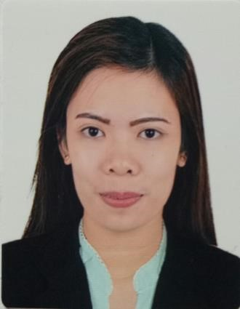
MARIZ

MARIZ.350827@2freemail.com

CAREER OBJECTIVE

To pursue a challenging position with a vision towards the future, wherein I can enhance my skills and capabilities and use it for achieving company’s goals and be part of its growth and development.

PERSONAL PROFILES

- Broad knowledge in accounting skills
- Knowledgeable in Microsoft and Excel
- Good communication and inter-personal competence
- Ability to function and adapt in a multi-cultural working environment
- Able to identify individual company requirements and establish relationship thus fostering confidence and trust.
- Fast learner, open to new ideas and willing to learn
- Able to cope under pressure at busy times and responds to deadlines
- Eagerly accepts new challenges and a team player
- Customer service oriented
- Stress tolerance
- Patience
- Persuasive

EDUCATION

Bachelor of Science in Accountancy in Polytechnic University of the Philippines Sta. Mesa Manila, Main (2009-2013)

WORK EXPERIENCE

SM Department Stores
Sales Associates
May 2013 to Nov 2013
- greet customers and find out the customer's needs
- describe a product's features and benefits
- make suggestions and encourage purchase of products
- maintain sales records
- stay current with sales prices
- recognize and monitor security issues
- arrange and display merchandise
- keep merchandise area tidy
- take stock inventory
- requisition new stock

Banco De Oro Universal Bank
Customer Service Assistant/Teller
Dec 2013 to Dec 2014

- Arrange monies received in cash boxes and coin dispensers per denomination.
- Balance currency, coin, and checks in cash drawers at ends of shifts, and calculate daily transactions using computers, calculators, or adding machines.
- Cash checks and pay out money after verifying that signatures are correct.
- Receive checks and examine for endorsements, verify amounts, and check accuracy of deposit slips
- Inform customers about foreign currency regulations, and compute transaction fees for currency exchanges.
- Transact remittances and telegraphic transfer
- Perform currency conversion, and exchange like buying and selling of other currencies
- Explain, promote, or sell products or services such as credit cards, insurance, money market fund, bonds and equity placement by providing computerized information about customers to tailor recommendations.
- Sort and file deposit slips and checks
- Compute financial fees, interest, and service charges
- Obtain and process information required for the provision of services, such as opening accounts, savings plans, etc.

Banco De Oro Universal Bank
Accounting Assistant/3
Jan 2015 – Jan 2017

- Preparation of daily and monthly reports base on financial statement
- Check the correctness and balance the transactions done by the teller
- Review all the transaction documents, reports and other selected GL accounts
- Preparation of GL entries and manual adjusting entries for erroneous validation from previous day transaction
- Processing of Outward Check sent to clearing house
- Perform error correction if there is any,
- Reversal of entry if needed,
- Perform final balancing of all the transactions for the day and ensure that the actual cash is balance versus the reports at the end of the day
- Prepares asset, liability, and capital account entries by compiling and analyzing account information
- Recommends financial actions by analyzing accounting options
- Summarizes current financial status by collecting information; preparing balance sheet, profit and loss statement, and other reports
- Substantiates financial transactions by auditing documents
- Reconciles financial discrepancies by collecting and analyzing account information
- Secures financial information by completing data base backups

COMPANY BACKGROUND
BDO Unibank, Inc. is the largest bank in the Philippines, the 116th largest bank in Asia, and the 234rd largest bank globally. BDO Unibank is also a member of SM Group owned by Henry Sy. The firm is a full-service universal bank. It provides products and services to the retail and corporate markets including lending (corporate, middle market, SME, and consumer, deposit-taking, foreign exchange, brokering, trust and investments, credit cards, corporate cash management and remittances. Through its subsidiaries, the bank offers leasing and financing, investment banking, private banking, bank assurance, insurance brokerage and stock brokerage services.

