Igor

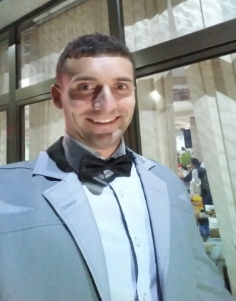
Igor.350837@2freemail.com
Current job
Jun 2016 - Present | Sports Center “Cair”
Swimming instructor, fitness instructor, lifeguard

Provide competent, safe instruction using recognized lead-up skills
Plan and effectively organize class time for maximum practice.
Teach with encouragement and positive reinforcement.
Provide for consistency in instruction by working each assigned period.

Demonstrate the correct way to use exercise equipment. Monitor the misuse of equipment. Deliver exercise classes and workshops. Develop personal exercise and diet plans.

Keep an eye out for people indulging in recreational activities on a pool. Supervising swimmers. Spotting hazards and preventing accidents. Giving advice on water safety. Controlling unruly behavior. Water rescue.

Previous work experience
Jan. 2016 – Jun 2016 | Leoni Malosiste, Serbia
Worker on the line, installation of cables
Aug. 2015 – Nov. 2015 | Leoni Bistrita, Romania
Worker on the line, inspection of cable

HOME COUNTRY WORK EXPERIENCE

Jan. 2010 – Aug. 2015 | Swimming Club “ Nis 2005 “ Serbia
Swimming coach
Working with swimmers to perfect their technique and prepare for a big competition based on individual needs or in a team. Expert in rules, strategies and techniques in swimming. Good connoisseur of sports equipment, necessary safety measures and physical fitness. Experience of working in a professional or amateur teams and as a personal trainer.
Responsibilities as a swim coach:
Selection of players Finding a strategy that best suits the talents of athletes Mental preparation of athletes for competition Assessment of health status of swimmers Planning a training program.
Skills and qualities as a swim coach:
The ability to draw well-balanced team. Recognizing the potential of swimmers. Finding and attracting good swimmers. Developed communication and supervisory skills. Thoughtful decision making in stressful situations. Maturity and self-confidence Education in the field of sports, swimming and anatomy.

EDUCATION AND TRAININGS

Maj 2009 – Sep 2011 | Sports Center “Cair”
Lifeguard
Certified lifeguard with more that 13 years professional swimming career. Excellent swimming skills and rescue drowning.

Oct. 2005 – Maj 2007 | University for Sport and Physical education
Assistant professor in College of Sports and Physical Education in swimming
Working with students to improvement techniques, improvement conditions, start jump and turned in swimming for exam. Always there to answer questions and give advice.

Graduated Sep 2013 | University for Sport and Physical education
Sep. 2001 – Maj 2005 | Electrotechnical School “Nikola Tesla”

Drivers license B category

COURSES

WORK ON COMPUTER

LANGUAGES

PERSONAL CHARACTERISTIC

TRAVEL HISTORY

Others

Certificate for swimming coach
Certificate for lifeguard

Profesional swimmer 13. year in swimming club “ Nis 2005 “

MS Office (Outlook, Word, Excel and Power Point)
Internet

Serbian | Native
English | Speaking | Good
 | Writing | Good
 | Reading | Good

b
Excellent communication skills, very good ability to work with demanding people, team work, always ready for further learning and advanced training, ready to work under pressure and overtime

Year of travel | Countries
2016 | Montenegro
2015 | Turkey, Romania
2014 | /
2013 | Turkey
2012 | Macedonia, Greece

