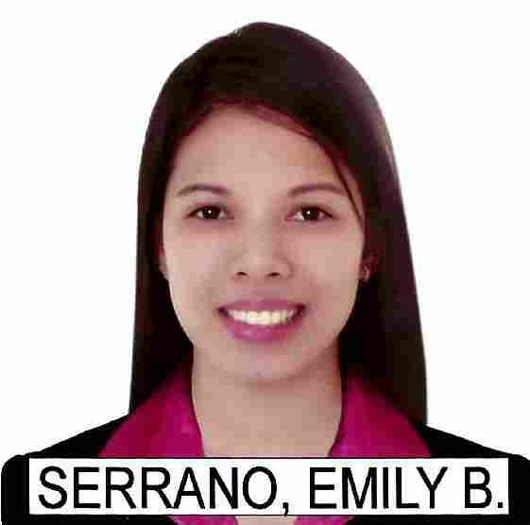
Emily

Emily.350873@2freemail.com

QUALIFICATIONS:

- Health of Authority Abu Dhabi PASSER
- Registered Medical Technologist of the Republic of the Philippines

- Total Years of Experience: 5 years and 8 months

OBJECTIVE:

To join in prestigious Medical Clinics/hospital that enhances my qualification, knowledge and skills. To be exposing in all sophisticated machine and latest procedures that can enhance my professional career.
To work with different types of personality that can continue my personality development.

JOB DESCRIPTION:

I am Emily Serrano, Registered Medical Laboratory Technologist with more than 5 years of experience and training of receiving samples, check for sample acceptance and rejection and document them with proper follow up. Segregate, centrifuge and process samples to perform test in Hematology, Chemistry, Microbiology, Endocrinology, Immunology under the control of laboratory policies, SOP’S, Laboratory Information System (LIS) and complete documentation in the logbooks. Monitor Stocks Level/Expiration date and a well knowledge of performing Internal/External laboratory control and do corrective actions.

WORK EXPERIENCE:

Asiatic Medical Laboratories Inc.
(808 Ongpin Street Sta. Cruz, Manila, Philippines)

ACHIEVEMENTS:

- Health of Authority Abu Dhabi Passer
- Registered Medical Technologist of the Republic of the Philippines
- Basic Life Support (September 2015-2017)

EDUCATION:
Centro Escolar University Bachelor of Science in Medical Technology
(Mendiola, Manila) June 2007- March 2011

Tugatog National High School High school level
(Dr. Lazcano St., Malabon City) June 2003- March 2007

Andres Bonifacio Elementary School Elementary Level
(Sangandaan, Caloocan City) June 1997-March 2003

CLINICAL INTERNSHIP PROGRAM:

Jose R. Reyes Memorial Medical Center October 2011-2012
Department of Head
(San Lazaro Compound,Sta. Cruz, Manila)

Skills:

- Friendly, dedicated, self-motivated, and versatile at handling multiple tasks in a pressurized working place
- Good communication skills and can get along with persons well
- Easy to adapt to the assigned area
- Goal oriented
- Can inspire and motivate people
- Patient oriented
- Adept problem solver
- IT skills: MS Word, PowerPoint, Excel and Internet

PERSONAL DETAILS:

Age: 26 yrs. old
Date of Birth: 11 July 1990
Religion: Roman Catholic
Civil Status: Married
Nationality: Filipino

I hereby attest that all above information is true.

