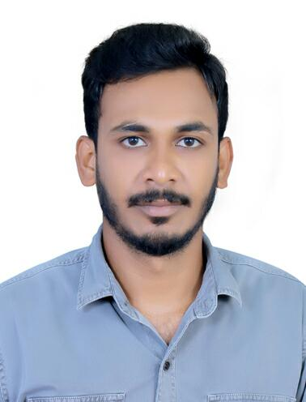
Razak
Mob. No. C/o 971506425478
Email : razak.350909@2freemail.com
Nationality : Indian
Date of Birth : 12th June 1990
Religion : Muslim
Marital Status : Unmarried

Objective
To achieve a position in the corporate world that will enable me to prove my interpersonal skills so as to provide opportunity for future growth and achievements. To challenge myself which will allow me to use and develop my skills while contributing to the entity’s goals. I ensure my full contribution and sincere hard work towards the applied position.

Work Experiences
- Date: 2012– 2013
- Name of employer : LG Electronics, India
- Position Held : Air Conditioning Mechanic
- Responsibilities : Estimate mechanical Works, preparing technical responses to the client comments. Verify the mechanical documents and record, submit to the client and obtain approval. Plan and monitor the progress of mechanical works.

- Date : 20013- 2014
- Name of employer: LG Electronics, India
- Position held : Sales Executive
- Main activities and responsibilities: Communication and Customer Relations activities. Planning and issuing the right advertising tools to promote new offers. Maintaining the relation with various suppliers. Primary book keeping activities. Creating newsletters.

- Date :2014-2016
- Name of Employer: Mc. Donald’s.,Dubai Mall, Dubai,U A E
- Position held : Service crew, Delivery Man
- Main activities and responsibilities: Cook food orders and maintain proficiency at every station. Back up other crew members to keep team workflow at efficient level. Monitor dining room and report any issues. Clean dining area and front counter. Put up deliveries, stocking shelves and resupplying dining area, kitchen and counter areas. Help new crew member get up to speed with protocols and restaurant practices.

Education
- Diploma in Air Conditioning Engineering from I.E.T.S Kerala, India – 2012

- Higher Secondary School, Kerala, India in 2009

Personal Skills
- Ability to work under stress and emergency situation.
- Hardworking and determined, sincere team player.
- Desire to learn and get trained.
- Comprehensive problem solving abilities.
- Willingness to adapt to new technologies and environments.
- Good communication Skills.
- Team spirit, excellent organizational and administravie skills
- Skilled in Customer Satisfaction, ability to identifiy and solve customer needs
Languages known

Malayalam
Hindi, Tamil – Fluent
English, Arabic – Advanced

- Hobbies Music, Cooking, Photography

Passport Details

Place of Issue : Cochin
Date of Issue : 13/12/2011
Date of Expiry : 12/12/2021

License Details

Holding Valid U.A.E Motorcycle Driving License
Place of Issue : Dubai
Date of Issue : 26/07/2015
Date of Expiry : 02/08/2025

Declaration
I hereby declare that all the information furnished above is true and correct.

RAZAK

