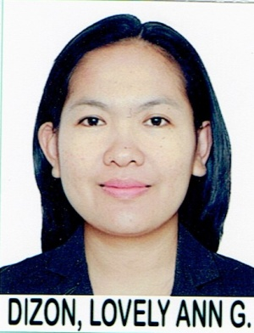
LOVELY
LOVELY.351008@2freemail.com

Capability

Flexible, a person who is willing to work on extended shifts, adaptable to multi-tasking and is able to work under pressure. Most highly valued skills are the ability to strive for solutions and manage relationships.

Career Summary
IQRA English School for Girls August 2016- February 2017
Magalang Christian Ecumenical School, Inc. June 2006- March 2016

Education
Master’s Degree April 2012
Pampanga Agricultural College

Bachelor of Elementary Education April 2006
Cum Laude
Best Student Teacher
Pampanga Agricultural College

Employment History
IQRA , Class Teacher August 2016- February 2017
IQRA English School is a British style school which uses a modified curriculum of English and Wales.

MCESI, Teacher and Pre-school Coordinator June 2006- March 2016
MCESI is a private school with the highest number of enrolees among the private schools in Pampanga. It is hailed as the champion in both academic and sports competitions.

Key Responsibilities
- Supervises six to seven faculty members
- Prepares annual schedule for the teachers
- Evaluates pupils’ and teachers’ performance
- Reviews qualifications of teacher applicants
- Represents the school during meetings with other private schools
- Teaches graders and pre-schoolers

Achievements
- Coached pupils who won in different academic competitions such quiz bee, spelling bee and poem delivery
- Judged various competitions of other schools

Professional Qualifications
- Passer of Licensure Examination for Teachers
- Civil Service Eligible

Referees
Available upon request

