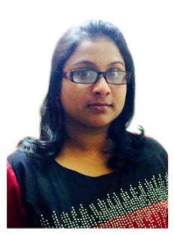
CURRICULAM VITAE
HANNA
E-mail: HANNA.351052@2freemail.com
OBJECTIVE:-
I am a punctual and motivated individual who is able to work in a busy environment and produce high standards of work. I am an excellent team worker and am able to take instructions from all levels and build up good working relationships with all colleagues. I am flexible, reliable and possess excellent time keeping skills.

PERSONAL EXPERIENCE:-

MEENU’S ENTERPRISES Cochin, Kerala INDIA.
Accounts Assistant JULY 2015 TO NOV 2017

FUNCTIONAL SKILLS:-

- Petty cash handling.
- Bank Reconciliation,
- Party Reconciliation (Sundry Debtors / Creditors)
- Handling financial accounts statements (Receivables & Payables) ageing report.
- Inventory reconciliation, inventory management, periodical bank submissions.
- Trial Balance, Profit & Loss A/c.

PERSONAL SKILL:-
- Self motivated and capable of thinking innovatively.
- Dynamic and confidence.
- Responsible and concentrate
- Time management.
- Problem Solving.
- Excellent Negotiation skill,
- Ability to work under stressful and difficult condition.

QUALIFICATION:-
- BECHLOUR OF ARTS (B.A) MG University 2014.
- PLUS TWO (XII) / SSLC (X)
- MS OFFICE, e-MAIL & INTERNET APPLICATIONS.
- DIPLOMA IN PROFESSIONAL ACCOUNTING (TALLY ERP 9)
- OFFICE ADMINISTRATION COURSE FROM ICICI ACADEMY FOR SKILLS BANGLORE.
- DIPLOMA IN COMPUTER APPLICATION STUDIED AT RUTRONIX CENTER KERALA.

INTERNSHIP :-

Publication Relation at General Hospital Pathanamthitta, Kerala INDIA.
Publication Relation with Padmavathy Medical Foundations, Kerala INDIA.

PERSONAL DATA
Date of Birth : 14/12/1990
Nationality : Indian
Marital Status : Married
Visa Status : Visit Visa
Visa Expiry : 18-APR-2017
Languages Known : Malayalam, English.

DECLARATION:-
I hereby declare that the details furnished above are true and correct to the best of my knowledge and belief. During my career span, I fulfilled my duties with clear and conscious mind.

‘’TRUST IS EARNED WHEN ACTIONS MEETS WORDS’’.

