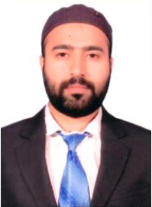
Shahnawaz
Shahnawaz.351066@2freemail.com

Educational Background
BCA (Bachelor of Computer Application)
BarkatUllah University, Bhopal, India

TECHNICAL SKILLS
- Master in Excel, MS Word, PageMaker, Corel Draw, Photoshop & Beginner Level PC Hardware.

UAE WORK EXPERIENCE 2 Year’s
Etisalat Sharjah Al Jubail.
Role: - Sales & Support Call center
Since 23-March-2015 – Contract is getting over 22-March-2017

India WORK EXPERIENCE 11 Year’s

- 1 Year 2014-2015 CI Hyundai Automobile Authorized Dealer
Role: - CRE.
- 1 Year 2013-2014 Jeewan Motors Maruti Authorized Dealer
Role: - EDP Executive.
- 1 Year 2012-2013 Sutherland Global Services
Role: - Schlumberger GJMC Support Executive.
- 1 Year 2011-2012 Reliance DAKC
Role: - CRE in Prepaid Dept.
- 3 Year’s 2008-2011 Vodafone
Role: - Team Leader Collection Team.
- 4 Year’s 2004-2008 Airtel
Role: - Collection Executive.

PERSONAL INFORMATON

Date of Birth : 03-12-1983

Marital Status : Married

Nationality : Indian

Languages known : English, Hindi, Urdu and Arabic.

UAE Driving Licence : Manual Valid Until November-2026

