ANTONY.351069@2freemail.com

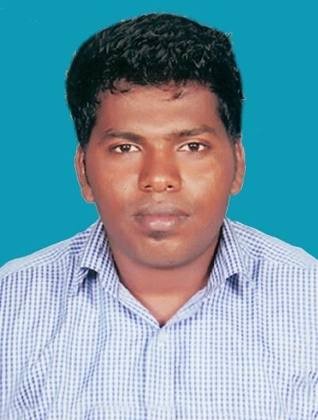Objective:
ANTONY
Master of Science in Software Engineering

Sex
: Male

Nationality
: Indian
Marital Status : Single
Languages
: English, Tamil.

To be a part of a progressive firm offering an opportunity for career advancement and professional growth in Operations Administration where I can use my skills and knowledge to help the company and my coworkers be successful.
Summary:
- Providing administrative support along with clerical tasks that aid the daily business operations of an organization.
- Provide upper management with insights to further increase productivity.
- Coordination, Supervision with the management regarding internal and external process.
- Experience in System Administration, Installation and maintenance of Microsoft Windows operating systems.
- Maintaining computing environment by identifying network requirements, installing upgrades, monitoring network performance.
- Establishing network specifications by conferring with users; analyzing workflow, access, information, and security requirements.
- Install Configure, Maintain Networks, patching cables and connecting devices.

Institute Certification:
- Cisco Certified Network Associate (CCNA) Course Completed.

Educational Qualifications:
- Master of Science in Software Engineering with First Class
from Sathyabama University – Chennai, Tamil Nadu, India.

- HSC with 55% from St. Joseph’s Hr. Sec. School, TN, India.

- SSLC with 65% from St. Joseph’s Hr. Sec. School, TN, India.

Technical Skills:
Operating System : Windows 10, Windows 7, Windows XP,
Windows Packages : MS Office, MS Excel, MS Word,
MS Power point
Programming Languages : C, C++

Total Year Of Experience:
Around 4 years experience including Operations Management and Desktop Support.

Snap Shot Of Experience:

Worked as Associate in Production Department (Central Operations) at OYO in DELHI - From July 2015 to February 2017

Industry Name : Oravel Stays Pvt Ltd (India)
Industry Type : Hospitality
Position : Operations Associate
Duration : 1 Year and 8 Months
Team size : 26

As directed by the management team, improve processes and policies in support of organizational goals.
- Perform any other duties or responsibilities consistent with the role as assigned by management.
- Coordinate with other support departments for problem solving and cooperate with the relationship managers for decision-making.
- Resolving client issues and inspecting merchandise.
- Ensuring/Checking the whole process of all Internal and External (City) Team.
- Understand client business issues, operating business rules, data and standard operating procedures.
- Resolving the city team Issues/Complaints.
- Operate business processes for clients on a periodic basis, synthesizing data and performing quality checks.
- Interact with internal and client teams.
- Respond to the query from the clients.
- Manage the corporate relationship base of the assigned Team / business.
- Worked on CRM (Sales force).
- Formulate and implement organizational policies and procedures as needed.

- Worked as a Desktop Support Engineer at JVS Tech in Kanyakumari – From July 2013 to May 2015

Industry Name : JVS Tech Pvt Ltd (India)
Industry Type : Information Technology
Position : Desktop Support Engineer
Duration : 2 Years
Team size : 12

- Installation of LAN.
- Software Installation.
- Installing and updating the Antivirus.
- Setting-up the Administrative settings of the firm.
- Install ,Configure, maintain networks services, equipment and devices
- Provides training to Operation Executives for up gradation and services.
- Configuring Wireless LAN for Intranet and Internet Users.
- Maintaining and troubleshooting WAN/LAN connectivity of our Department network.
- Installing, Configuring, Administering and Implementing Windows 2000, Windows XP, Windows 7.

Passport & Visa Details:

Date of Expiry : 06-06-2023

Place of Issue : Madurai (Tamilnadu, India)

Visa Type : Long Time Visit Visa

Date of Visa Expiry : 01-June-2017

Date of Birth : 31-01-1991

Declaration:

I hereby declare that the above-furnished information’s are true to the best of my knowledge and belief.

