NISAR
NISAR.351072@2freemail.com
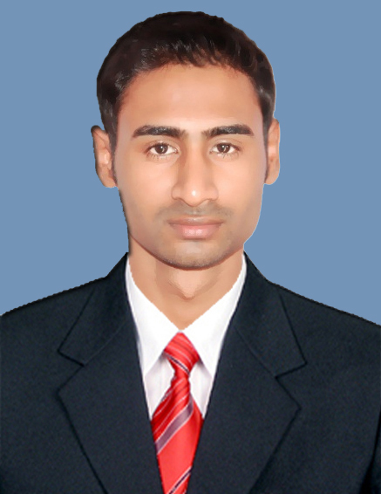

Languages Known

English, Malayalam, Hindi & Kannada.

CURRICULUM VITAE
Objective

Seeking for a Medical Coder position in a clinic/hospital where I can utilize my extensive computer and medical apparel knowledge, strong organizational abilities, demonstrating quality communications skills and patient service.

working, dedicated and a dependable person who is looking for a good career opening.

Educational Qualification

Professional
- CPC (Certified Professional Coder) Certified from AAPC (American Academy of Professional Coding)(2012).
- Advanced Medical Coding and Billing (ICD-9CM, CPT-4, HCPCS Level ll) from Aldos Medical Services Pvt.Ltd, Bangalore.
Academic
- BCA from Karnataka University Dharwad (KUD)(2011).
- Plus Two Science from Pre-University Education Board Karnataka (2008).

Working Experience

- Overall experience of 3.5 years in the field of Medical Coding.
- Currently working as a Medical Coder in UniCare Medical Centre, Dubai.(Aug 2016 to cont)
- Worked as a Medical Coder in Burjeel Hospital for Advanced Surgery, Dubai .(July 2014 to July 2016)
- Worked as a Medical Coder in E/M Department at Vee Technologies Pvt. Ltd, Bangalore.(Feb 2013 to Mar 2014)

- AAPC CERTIFIED PROFESSIONAL CODER (CPC).
Affiliations

- MEMBERSHIP : AAPC , Membership
Key Professional Skills

- Prepare cost estimates mainly for various out-patient and in-patient cases.
- Code medical records with ICD-9CM,ICD10, CPT-4, and HCPCS Level II coding.
- Processing claims daily while maintaining accuracy and achieving productivity goals.
- Seeking approval for currently hospitalized cases to aid a smooth discharge process.
- Contact Insurance Companies for verbal approval for necessary cases.
- Coordinates with external and internal clients for approval-related information.
- Coordinated Coding with Medical Transcriptionists and Front Desk Staff.
- Handling the wide variety of medical claims including physical therapies, surgeries and diagnostic testing.
- Very sound knowledge of medical terminology and codingICD-9CM,ICD 10,CPT-4,HCPCS Level ll, physiology and pharmacology.
- Review the In-patient list and OT list to ensure proper approval status on a daily basis
- Proficient in computers like MS word, MS excel and other MS office tool.
- Excellent in communication, interpersonal and organizational skills.
- Well maintained and proficient with the financial records.

Personal Skills

- Analytical and Problem Solving.
- High degree of grasping power.
- Ability to motivate and inspire confidence in the team.
- Hardworking and dedicated to the companies objectives.
- Strong time management skills

Declaration
I hereby declare that all the above-mentioned information is true to the best of my knowledge and belief. I would take this opportunity to thank you for going through my resume and would request you to consider me to be a part of your prestigious organization.

