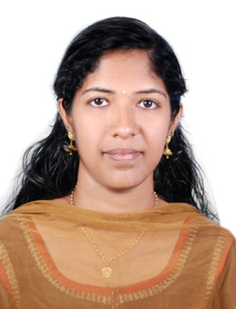

LOOKING FOR THE POST OF
TEACHER

Please scan to capture contact details

Looking

SISIRA
SISIRA.351099@2freemail.com

OFFICE ASSISTANT - SECRETARY

CAREER OBJECTIVE

Looking for a high-grown organization with a competitive and challenging environment that creates an ideal condition for delivering high quality services. Aspiring to associate with an organization, which offers a congenial environment for growth.
HIGHLIGHTS OF QUALIFICATIONS
- Demonstrated capacity to provide comprehensive support for senior-level staff, including managing and coordinating projects and processes in support of effective business operations
- Proven track record of accurately maintaining detailed records, generating reports, coordinating meetings, and multitasking within fast-paced atmospheres
- Strong work ethic and superior interpersonal, customer service and communication skills.
- Excellent communicator, both written and oral.
- Team player; quickly and easily establish professional rapport with coworkers.
- Knowledgeable in Microsoft office applications (Word, Excel, Power Point, Office, etc.)
- Friendly, courteous, and with a good sense of humor.
- Excellent time management skills that allow for the multi-tasking of all responsibilities

Education
- Ms office ( in 2012 )
- MASTER DEGREE ( MSc SCIENCE in 2011 )
- BATCHELOR DEGREE ( BSc SCIENCE in 2009 )
- Intermediate ( SECONDARY SCHOOL CERTIFICATE IN 2006)
- Metric ( HIGH SCHOOL CERTIFICATE IN 2004)

Career History

ACE COLLEGE AT THRISSUR,KERALA

JOB TITLE : LECTURER In computer science
FROM : 2011 to 2013

RED BUDS ADVERTISEMENT COMPANY AT THRISSUR,KERALA

JOB TITLE : OFFICE ADMINISTRATIVE
FROM : 2013 To 2015

strengths

- Skilled in computer knowledge ( ms office word excel etc,….)
- Client Service - Ability to respond to the clients and anticipate their needs.
- Document Use – Maintaining of operation log books and Ability to use and understand documents.
- Excellent communication - Can use language effectively to gather information and facilitate the exchange of ideas.
- Oral Communication - Skilled at oral communication and can express oneself in conversations and when addressing an audience
- Persuasive Communication - Skilled at both oral and written communication that can influence others
- Results Oriented - Achieves goals in a timely manner while providing excellent client service.
- Very Strong Ability to favorably represent the Company image to clients
- Sound Ability to work independently and in a team oriented environment

hobbies

- Reading Books.
- Listening to Music.
- Cooking…
- Searching in internet….

Personal details

Nationality: Indian
Marital Status: married
Visa status: visit visa (up to April 20)
Date of Birth: 29th July 1989
Language Proficiency: English, Hindi, Malayalam, and Tamil.

declaration

I hereby declare that all the above mentioned information is correct to my knowledge and I hear the responsibility for the correctness of the above mentioned particulars.
:

