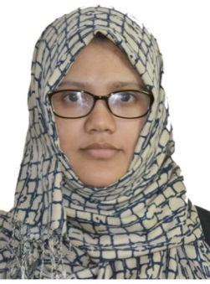
FARSANA
FARSANA.351101@2freemail.com

OBJECTIVE: Seeking a Data Entry Operator position at Aljaber Group utilizing extensive typing ability and great communication skills to maximize efficiency of office.

MAJOR QUALIFICATIONS
• Over 1 year’s data entry experience
• Highly skilled in operating a variety of office machines and equipment such as computer, fax, scanner and copier
• In-depth knowledge of MS Office applications (Word, PowerPoint and Excel)
CORE COMPETENCIES
• Relationship building
• Proactive approach
PROFESSIONAL EXPERIENCE
Libra Printing Press May 2011 – jun2012
Data Entry Operator
• Perform general data entry using Microsoft Excel and Word.
• Input data into a variety of computer programs with pace and correctness
• Answer phones and create notifications in the system
• Contact with internal and external customers

SSI Computer Center Dec2010 – Mar 2011
Computer Operator
• Performed data entry-alpha and numeric data entry to add new records, verify, correct, edit, and change
• Utilized scanner, copier, telephone, fax machine, and printer to perform tasks

EDUCATION
Master of Computer Applications
BSc Computer Science

PROFESSIOANL QUALIFICATION
MS office, DCA

IT SKILLS
Personal Computer Knowledge
Database Technology: SQL, MySQL, MS-OFFICE (EXCEL, ACCESS, POWERPOINT, WORD) 2010
Operating Systems: Windows 2010, 07 & Win XP.
Language: Basic, Visual FoxPro, C, C++, C #

ADDITIONAL CAPABILITIES
• Positive attitude and excellent interpersonal skills

PERSONAL DATA
Date of birth 26 May1986
Nationality Indian
Religion Muslim
Marital status Married
Visa Status Husband Visa

DECLARATION
I hereby declare that all the details furnished above are true to the best of my knowledge.

