CURRICULUM vITAE

zahid

Objective:

Intend to attach, grow & consolidate in a professionally managed and growth oriented organization, which concentrates on client relations and requires quick learning capabilities, while concurrently upgrading attitude, skills and knowledge through teamwork and leadership and to achieve the common organizational goal including my growth.

Zahid.351126@2freemail.com

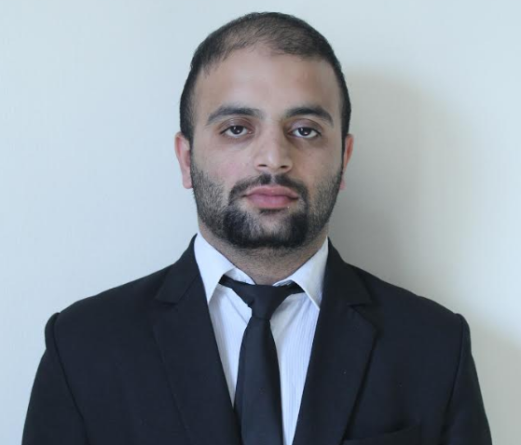
ZAHID

PERSONAL
INFORMATION___________________________________________________________________
- Date of Birth  - Nationality  - Marital Status  - Health  - Religion  - Valid UAE Driving | : 14-04-1994  : Indian  : Single  : Excellent  : Muslim  License
EDUCATION
HISTORY________________________________________________________________________

DIPLOMA : 3 year diploma IN ELECTRICAL ENGINEERING
PERSUING : B.TECH FROM AIIME FROM SRINAGAR, J&K ,INDIA
CERTIFICATIONS________________________________________________________________

- ONE YEAR COURSE ON AUTOCAD 2D FROM CADD CENTRE ,RAJBAGH SRINGAR
- SWIFT SMART COURSE FROM NIIT SRINAGAR
- One Year Computer Diploma From CTK SRINAGAR
- SIX MONTHS BASIC COURSE IN COMPUTER APPLICATIONS
- SIX MONTH ADHOE ADVENTURE -96 FROM JAWAHAR INSTITUTE OF MOUNTAINEERING AND WINTER SPORTS
- SIX MONTH DEVELOPMENT COURSE FROM KASHMIR UNIVERSITY

EMPLOYMENT HISTORY______________________________________________________________________

Company: BAGLIHAR POWER PROJECT
Period : NOVEMBER 2014 -SEPTEMBER2015
Position: J.E (JUNIOR ENGINEER)

Duties
- Manages and guides the team members and analysis the final output
- Prepares the functional direction in the development ,design as well as optimization
- Responsible for the development of team and also analysis the output as weather it falls under the client specification or not
- Responsible to enhance knowledge and ablity in the field of scientific analysis ,engineering principle and project management
- Read and distribute all essential communication relevant to team and clients
- Sanctioning of service connection as per power vested
- Respond and follow up to any issue
- Monitoring of works
- Billing the consumers in the jurisdictional area
- Maintenance of consumer accounts in the prescribed manner
- Action for prevention of theft of power
- Responsible for distinguishing concerns, identifying them and attaining solution to these concerns
- Examination of feasibility of power supply from existing infrastructure
Company: GEANT HYPERMARKET

Period :NOV 21 –Till present
Position :Electrical Supervisor

Duties
- Evaluates electrical systems, products, components, and applications by designing and conducting research programs; applying knowledge of electricity and materials.
- Confirms system's and components' capabilities by designing testing methods; testing properties.
- Develops electrical products by studying customer requirements; researching and testing manufacturing and assembly methods and materials.
- Develops manufacturing processes by designing and modifying equipment for building and assembling electrical components; soliciting observations from operators.
- Assures product quality by designing electrical testing methods; testing finished products and system capabilities.
- Prepares product reports by collecting, analyzing, and summarizing information and trends.
- Provides engineering information by answering questions and requests.
- Maintains product and company reputation by complying with federal and state regulations.
- Keeps equipment operational by following manufacturer's instructions and established procedures; requesting repair service.
- Maintains product data base by writing computer programs; entering data.
- Completes projects by training and guiding technicians.
- Maintains professional and technical knowledge by attending educational workshops; reviewing professional publications; establishing personal networks; participating in professional societies.
- Contributes to team effort by accomplishing related results as needed.

Mother Tongue
- KASHMIRI
Other Languages
- URDU, HINDI & ENGLISH

Organization Skills
- Ability to work effectively under pressure
- Time management and organization, ability to meet deadlines
- Good sense of priority on activities and tasks
- Multi-tasking and problem solving
Social Skills
- Good communication skills and team work
- Ability to adapt to multicultural environment
Technical Skills
- Advance Knowledge of Photoshop
- Proficient Knowledge of Internet, Computer Hardware and Software
- Proficient in Microsoft Office Tools (Word, Excel, Power Point and Outlook)
Additional Information
- I am available to travel and to relocate

I hereby authorize the use of my personal details solely for circulation within the company.

ZAHID

