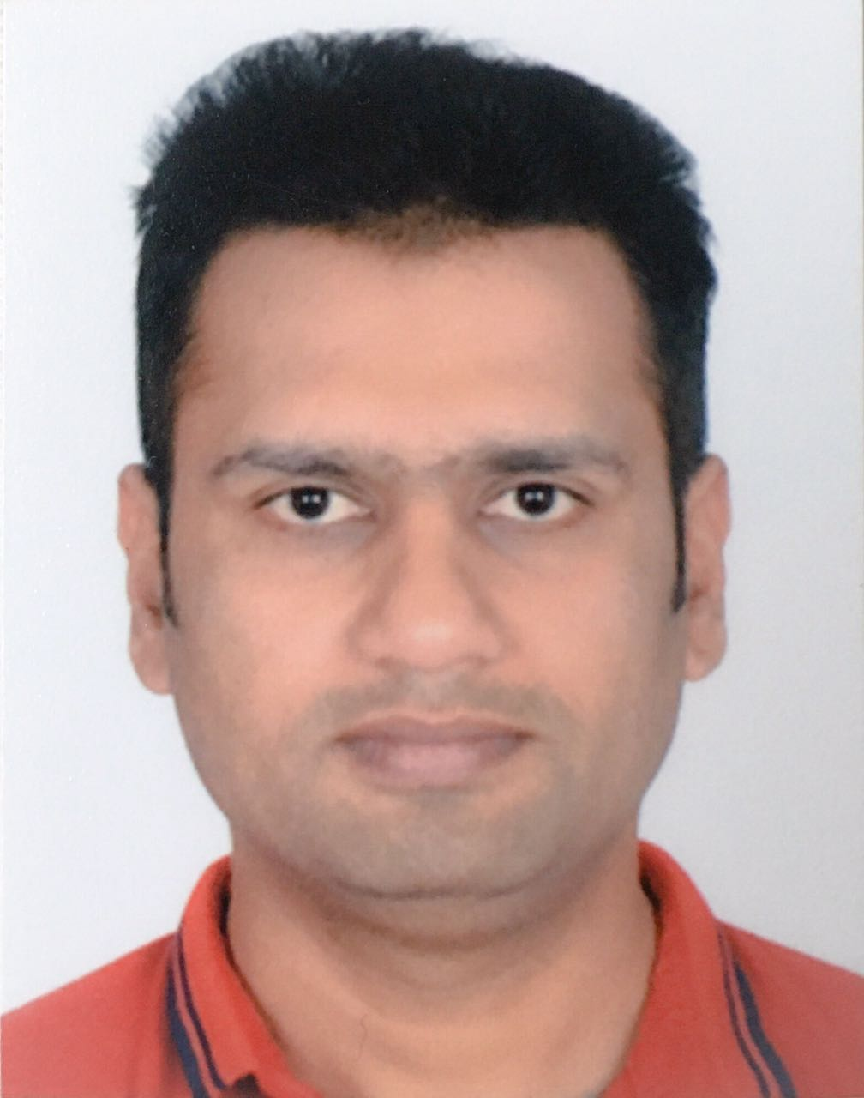
Dharmesh
dharmesh.351138@2freemail.com
_______________________________________________________________________________________________________________________________________
Dynamic and Flexible – Quick Problem Solving – Good Analytical

Objective

Seeking Middle Level Position inEngineering/Construction in growth oriented organization of repute.

Skills & Abilities

- Strong knowledge of Structural Steel, Masonry, Fabrication Design.
- Be able to Independently Function Construction Site.
- Be able to create good co-ordinations with superiors & sub-ordinates.
- Be able to draw Architectural Sketches.
- Be able to work independently as well as in a team.
- Excellent Communication skill in English Both verbal as well as written.
- Be able to use computer software such as MS Project,MS Office.
- Be able to operate Auto CAD.
- Sound Knowledge of Structural and Mechanical Engineering,
Pre-Stressed Structure, Rock Anchoring, Soil Retentionas well as
M.S Fabrication&M.SStructures.

Work Experience

Aug 2014 – Jan 2017
Hari Om Constructions-Pattathu Brothers Enterprise (HDIL)
Project: Gomes Town(Mumbai, India).

Achievement: Successfully completed 2 wings before the deadline assigned.

Job Description:
- Project Engineer for Residential Project (G+11 floors 7 Wings).
- Calling for quotations, preparing comparative statement and awarding contracts.
- Checking of Bills as per work done w.r.t. Work Order.
- Reconciliation of steel and Cement.
- Monitoring and managing Process of Review and Risk assessment.
- Made sure that quality of design Documentation is appropriate with work plan.
- Preparing Reports.
- Planned Execution of work with constant check on Quality Assurance.

Dharmesh
dharmesh.351138@2freemail.com
_______________________________________________________________________________________________________________________________________

June 2013 – June 2014
Devam Constructor
Project: Ajmera Iconic by Ajmera Cityscapes(Mumbai, India).

Achievement:- Successfully submitted Reconciliation statement
Job Description:
- Site management of Residential Project (G+3 Podium +17 floors).
- Reconciliation of steel and Cement.
- Checked and Evaluated design Calculation.
- Monitored and managed Process of Review and Risk assessment.
- Made sure that quality of design documentation is appropriate with company work plan.
- Planned Execution of work with constant check on QA/QC.

June 2010 – June 2013
Kawa Steel Works
Project: Various(Mumbai, India).

Job Description:
- Planning, management, Execution of Civil as well as Fabrication jobs.
- Purchase of Various Materials.
- Constructed G+7 floorTransit Camp.
- Structure Restorations.
- Girders and Trusses.

July 2007 - June 2010
J.N.Associates
Project: Pinnacle Business Park, Pooja Constructions(Mumbai, India).

Job Description:
- Site Management of Commercial Project.
- Monitored and Managed Process of Review and Risk assessment.
- Made sure that quality of Design Documentation is appropriate with companie’s work plan.
- Prepared Reports.
- Planned Execution of work with constant check on Quality Assurance.

Dharmesh
dharmesh.351138@2freemail.com

April 2007 - July 2007
J.N.Associates
Project: Satra Plaza, Satra Properties India Ltd. (Mumbai, India).

Achievement: Successfully completed assigned task of Constructing Sub structure(From Excavation,Raft Foundation and Double Basement up to Plinth Level).
Job Description:
- Site management of commercial project for an assigned job of constructing Sub Structure only.
- Planning and Execution of activities from Excavation to Plinth.
- Checked Form work and Reinforcement according to plan and suggested changes wherever needed.
- Preparing Reports.

March 2006 - April 2007
J.N.Associates
Project: Silver Leaf, Glomore Constructions. (Mumbai, India).

Job Description:
- Site management of Residential Project (S.R.A as well as Tower)
- Monitoring and Evaluate Progress of site.
- Managedsite with more than 60 site work forces.
- Prepared Reports.
- Checked Form work and steel work according to plan.
- Planned and Executed Casting of almost Every Structure.

May 2005 - March 2006
J.N.Associates
Project: (Dreams mall)Satra Park, Satra properties India Ltd. (Mumbai, India).

Role:
- Execution of site work.
- Checked formwork and steel work according to plan.
- Prepared Reports.
- Managed More than 50 site work forces.

Dharmesh
dharmesh.351138@2freemail.com
_______________________________________________________________________________________________________________________________________

Academic Credentials

- Successfully Completed Diploma in Civil Engineering (2010-2014) from Shree Bhagubhai Mafatlal Polytechnic, Vile Parle West, Mumbai.
- Appeared forBachelor’s Degree in Commerce and Economics in 2005 from PralhadraiDalmia Lions College of Commerce and Economics.(Mumbai University).
- Passed H.S.C (Mumbai University) in 2002 from PralhadraiDalmia Lions College of Commerce and Economics, Malad west, Mumbai.
- Completed E-commerce Course from ZEE Interactive Learning systems in 2002.
- Passed S.S.C (Mumbai University) in 2000 from Scholars Academy English Medium School.

Personal Details

- Language Proficiency : English,Hindi,Gujarati,Marathi.
- Date of Birth : 1st October 1984.

Declaration

- I hereby affirm that the above details are true and correct.
Dharmesh
UAE

