Muhammad
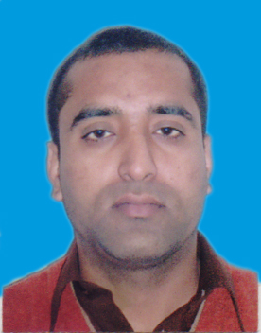
Muhammad.351211@2freemail.com

Personal Statement

Acquiring knowledge has always been a passion and motivation for me tounderstand different environment. As an experienced person in customer services I would like to render my services and build my career through hard work, dedication and achievements in the tasks I would be assigned in my job description, and prove to be an icon for the company I work for.
Education

MBA
Top up (2011-2012), BGS (Birmingham Graduate School) University of Wales UK.

P.G.D

Post Graduate Diploma in Strategic Management and Leadership (2011)
C.M.I (Chartered Management Institute) from LPC (Leeds professional college Leeds)

Diploma -Peachtree

Nicon Group of colleges (2010)

- B.com (IT)
Graduation (2010), Punjab College of commerce, Rawalpindi, University of the Punjab, Pakistan
- I.Com
Intermediate (2007),Punjab College of information technology Rawalpindi, Board of Intermediate & Secondary Education
- Matriculation
Science (2005), Govt. High School BuchalKalan
Intermediate & Secondary Education Islamabad Pakistan.

Career Snapshots

- Three year experience as manager export handling at Continental trade cooperation Peshawar Pakistan, major responsibilities were,
- Handling all workers in organization.
- Dealing with traders from other cities.
- Making relations with customers.
- Cash handling (Financial manager)
- Working as a shift manager Troy food Hunslet, Leeds, UK.
- Worked with different societies during study period to organize function and arranging meetings.
- Experience in customer services in Pakistan in family business.

