**Curriculum Vitae**

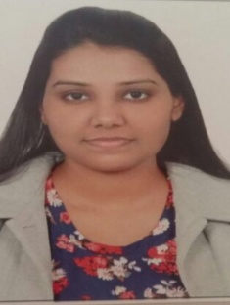

Anamika

[Anamika.351215@2freemail.com](mailto:Anamika.351215@2freemail.com)

**OBJECTIVE**

To make a positive impactin my field of activity leading to Organization growth by creative application of my value based convictions and professional divinity by putting my all efforts in the work assigned to me in an organization where I can grow along with the organization.

**PERSONAL STRENGTH**

* Sincerity towards job and punctuality.
* Able to cope under pressure.
* Excellent communication skills.
* Can work independently or as a part of team.

**WORK EXPERIENCE:**

➢  Worked as an accounts Trainee for 6 Months in a CA firm.

➢  4 years Private tuition and coaching centre teaching experience.

**ACADEMIC QUALIFICATION:**

|  |  |
| --- | --- |
| **2016** | Master of Commerce  Indra Gandhi National Open University (IGNOU) |
| **2013** | Bachelor Of Commerce  Delhi University |
| **2010** | Higher Secondary |
|  | Govt. Sarvodaya Senior Secondary School, New Delhi |
| **2008** | Secondary  Govt. Sarvodaya Senior Secondary School, New Delhi |

**Computer Proficiency:**

➢  Accounting Packages: Tally Erp 9 & 7.2

➢  Office Management: MS Office (Word, Excel and Power Point)

**VERNACULAR EFFICIENCY:**

➢      English, Hindi

**PERSONAL ATTRIBUTES:**

➢   Confident, Hard-working & Goal Oriented

**ACTIVITIES AND INTEREST:**

➢   Listening music and Singing